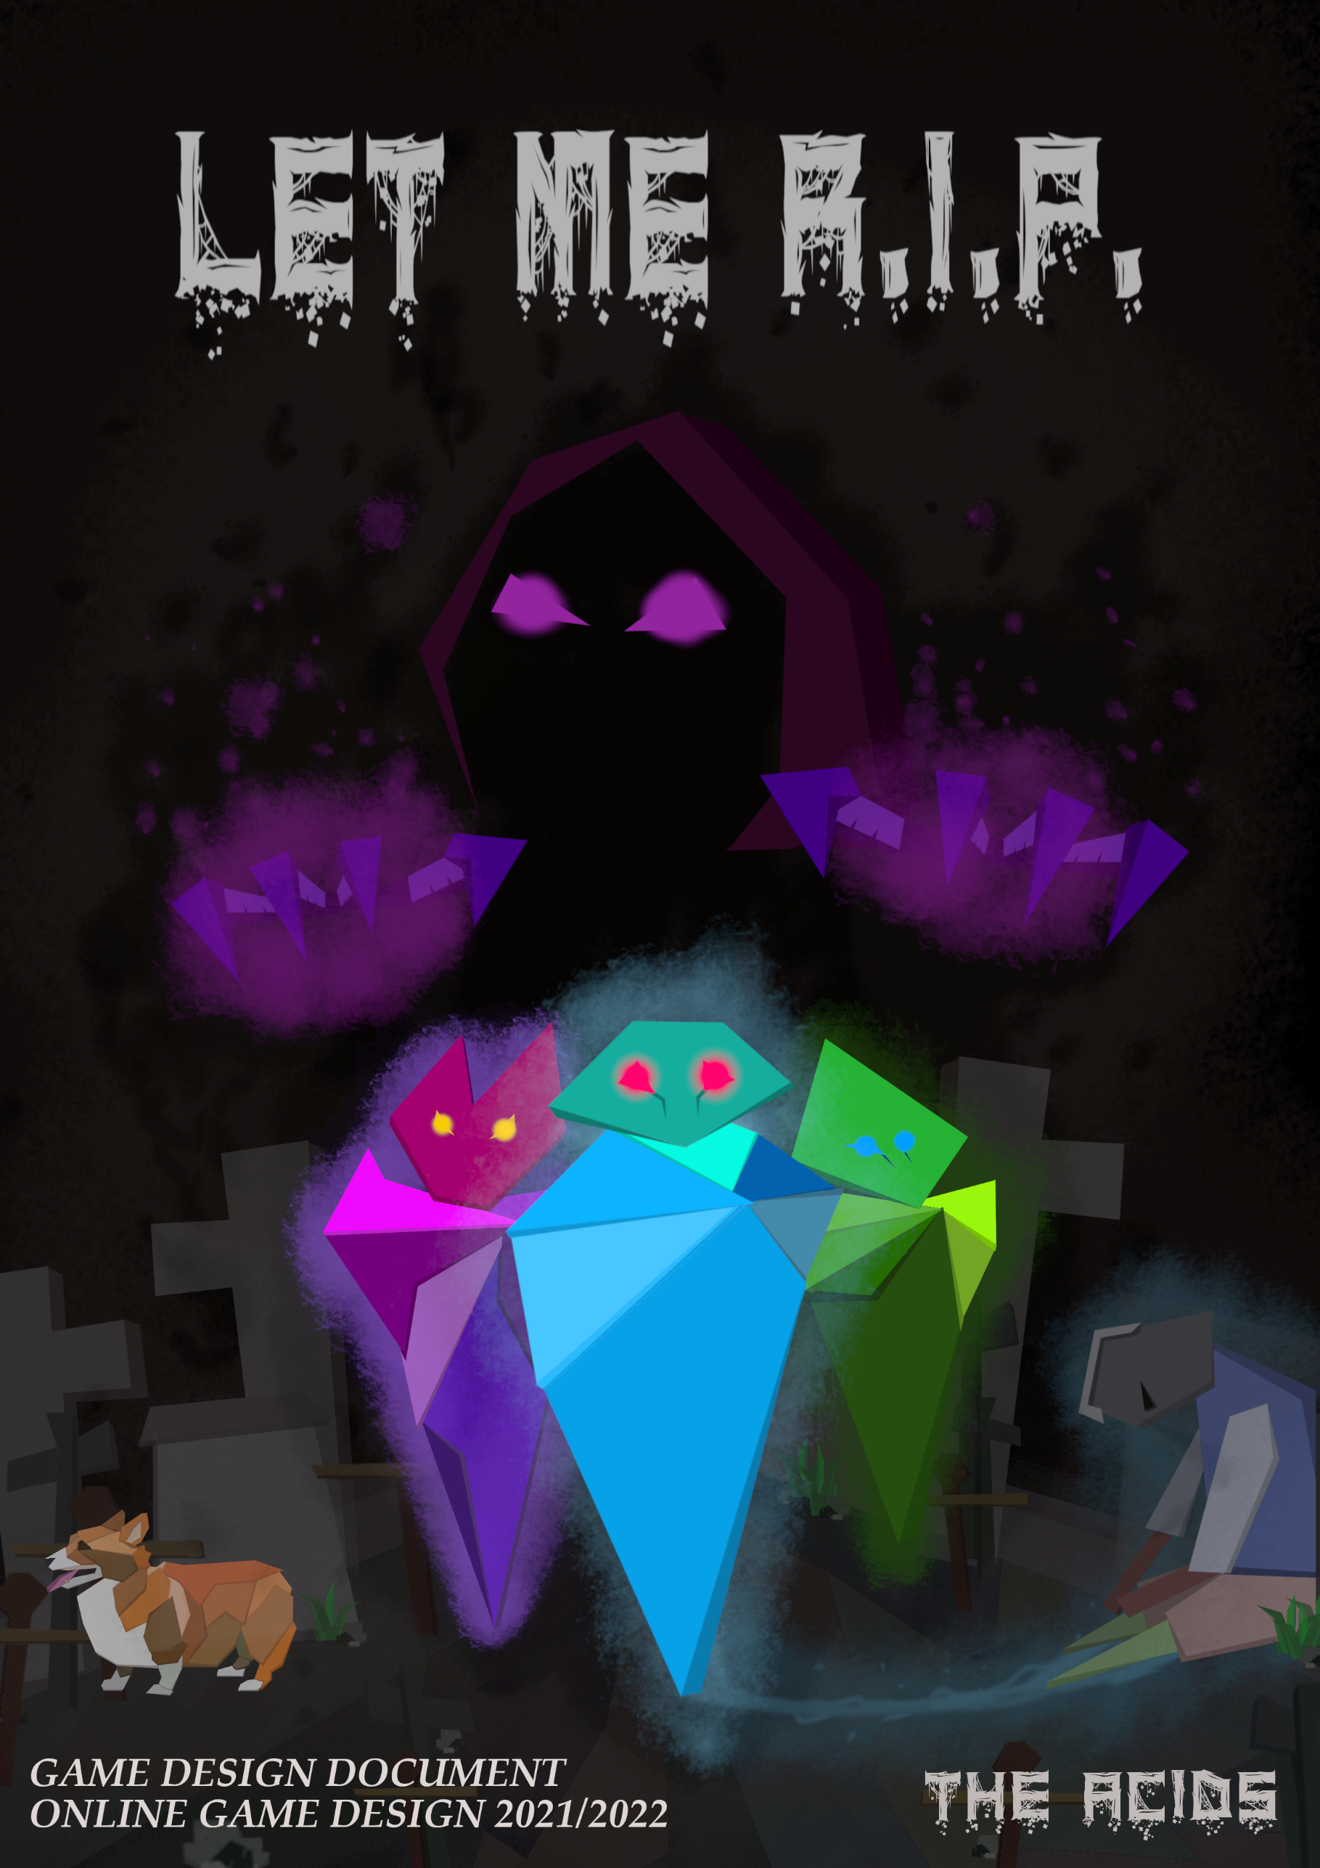

Content Table

THE ACIDS TEAM 5

1. DESIGN HISTORY 6

2. VISION STATEMENT 8

2.1. GAME LOGLINE 8

2.2. GAMEPLAY SYNOPSIS 8

3. AUDIENCE, PLATFORM, AND MARKETING 9

3.1. TARGET AUDIENCE 9

3.1.1. Bartel’s Taxonomy 9

3.1.2. Level of Expertise 10

3.1.3. Demographics 10

3.1.4. Gender Distribution 11

3.1.5. Geographic Distribution 12

3.2. PLATFORM 13

3.3. SYSTEM REQUIREMENTS 13

3.4. TOP PERFORMERS 14

3.4.1. Children of Morta 14

3.4.2. Diablo 3 15

3.4.3. Magicka 2 16

3.4.4. Monster Hunter: World 17

3.4.5. Hades 18

3.4.6. Dead Cells 19

3.5. FEATURE COMPARISON 20

3.6. PERSONAS 21

4. LEGAL ANALYSIS 24

5. GAMEPLAY 25

5.1. OVERVIEW 25

5.2. CORE MECHANICS 25

5.2.1. Resources 25

5.2.2. The Spirit Form 25

5.2.3. The Physical Form 26

5.2.4. Leveling 28

5.2.5. Classes & Transformations 29

5.2.6. Abilities 30

5.3. PLAYER STATISTICS 43

5.4. SHOPS 44

5.4.1. The Smelly Corpse 44

5.4.2. Milly the Tailor of Souls 44

5.4.3. Mercy 45

5.4.4. Consumables 45

5.5. MULTIPLAYER EXPERIENCE 49

5.5.1. Chat 49

5.5.2. Friends System 49

5.5.3. Invite Friends to Hub 49

5.5.4. Stat balancing 49

5.5.5. Special Multiplayer Dungeons 50

5.5.6. Balancing Dungeons’ Difficulty for multiple players 50

5.5.7. Dying 50

5.5.8. Disconnection 50

5.5.9. Achievements 51

5.6. CONTROLS 52

5.6.1. Key Bindings 52

5.6.2. Interfaces 54

5.6.3. Flowchart 63

6. GAME CHARACTERS 68

6.1. MAIN CHARACTERS 68

6.1.1. The Poor Soul 68

6.1.2. Gorb 68

6.1.3. Sally 68

6.2. ENEMIES 68

6.2.1. Calsifer 68

6.3. SIDE CHARACTERS 68

6.3.1. Schrodinger 68

6.3.2. Milly 68

6.3.3. Tain 68

6.3.4. Mercy 69

7. GAME WORLD 70

7.1. HUB 70

7.2. DUNGEONS 70

7.3. ROOMS 70

7.4. CARIAN DEPTHS 71

7.5. ALLIED CREATURES 72

7.6. ENEMIES 73

7.6.1. Calsifer 78

8. STORY 82

8.1. SYNOPSIS 82

8.2. COMPLETE STORY 82

8.3. BACKSTORY 84

8.4. NARRATIVE DEVICES 85

8.5. SUBPLOTS 85

8.5.1. Crestfallen Souls 85

9. MEDIA 86

9.1. CHARACTERS 86

9.1.1. Spirit 86

9.1.2. Bodies 87

9.2. BOSSES 96

9.2.1. Calsifer 96

9.3. ENEMIES 97

9.3.1. Simple Enemy 97

9.3.2. Caster 98

9.3.3. Summoner 98

9.3.4. Blocker 99

9.3.5. Spider Mother 99

9.3.6. Spiderling 100

9.3.7. Suicide 101

9.3.8. Crimson Tentacle 102

9.4. ENVIRONMENTS 103

9.4.1. Hub 103

9.4.2. Dungeon rooms 103

9.4.3. Red Lands 104

9.5. MUSIC 104

9.6. CARIAN DEPTHS 107

10. PROTOTYPES 108

10.1. PHYSICAL PROTOTYPE 108

10.2. DIGITAL PROTOTYPE 111

# THE ACIDS TEAM

ANDREA BORGHESI

952944

Game Design

Game Programming

Team Leader

[andrea.borghesi1@studenti.unimi.it](mailto:andrea.borghesi1@studenti.unimi.it)

ANDREI DANIEL BALANICA

941778

Game Design

Game Programming

[andreidaniel.balanica@studenti.unimi.it](mailto:andreidaniel.balanica@studenti.unimi.it)

ANDREA PASSINI

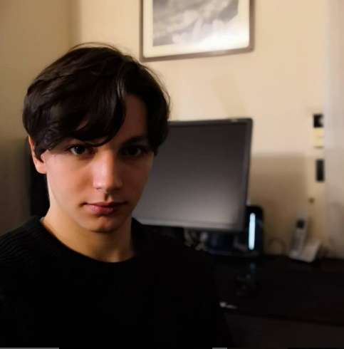991178

Game Design

Game Programming

[andrea.passini@studenti.unimi.it](mailto:andrea.passini@studenti.unimi.it)

# DESIGN HISTORY

|  |  |  |
| --- | --- | --- |
| People | Date | Changelog |
| Andrea Passini  Andrea Borghesi  Andrei Daniel Balanica | 14/04/22 | Backstory, Brainstorming |
| Andrea Passini  Andrea Borghesi | 15/04/22 | Gameplay |
| Andrea Passini  Andrea Borghesi  Andrei Daniel Balanica | 20/04/22 | Backstory Brainstorming using Microscope RPG |
| Andrea Passini  Andrei Daniel Balanica | 21/04/22 | Gameplay – spirit form |
| Andrei Daniel Balanica | 23/04/22 | Gameplay |
| Andrea Passini  Andrei Daniel Balanica | 28/04/22 | Gameplay, class abilities, interactions |
| Andrea Borghesi | 29/04/22 | Markets, Side characters, Player statistics |
| Andrea Passini  Andrea Borghesi  Andrei Daniel Balanica | 02/05/22 | Gameplay |
| Andrea Passini  Andrea Borghesi | 03/05/22 | Prototype |
| Andrea Passini  Andrea Borghesi | 09/05/22 | Backstory |
| Andrei Daniel Balanica | 09/05/22 | Game mechanics, Multiplayer features |
| Andrea Borghesi | 10/05/22 | Story |
| Andrea Borghesi | 11/05/22 | Story |
| Andrea Borghesi | 12/05/22 | Characters |
| Andrea Passini  Andrea Borghesi | 12/05/22 | Physical Prototype |
| Andrei Daniel Balanica | 14/05/22 | TDD |
| Andrea Passini | 14/05/22 | Gameplay |
| Andrea Passini  Andrea Borghesi | 15/05/22 | Gameplay |
| Andrea Passini  Andrea Borghesi | 16/05/22 | Gameplay |
| Andrea Passini  Andrea Borghesi | 17/05/22 | Storyboards  Gameplay |
| Andrei Daniel Balanica | 18/05/22 | TDD |
| Andrea Passini  Andrea Borghesi | 18/05/22 | Enemies and Potions |
| Andrea Passini  Andrea Borghesi | 19/05/22 | Visual and Audio Reference,  Subplot |
| Andrea Passini | 20/05/22 | Personas, Target Audience |
| Andrea Borghesi | 20/05/22 | Gameplay – Carian Caves, Legal analysis, Key bindings |
| Andrei Daniel Balanica | 20/05/22 | Networking Prototype |
| Andrea Borghesi | 21/05/22 | Vision statement update |
| Andrea Passini | 21/05/22 | Boss behavior |
| Andrea Borghesi | 22/05/22 | Multiplayer, Top performers, Controls, Storyboards game UI, Achievements |
| Andrea Passini | 22/05/22 | Concept Art |
| Andrea Borghesi  Andrea Passini | 23/05/22 | Storyboard and flowchart UI |
| Andrei Daniel Balanica | 23/05/22 | TDD, GDD finalization |

# VISION STATEMENT

## GAME LOGLINE

You are a simple soul, wanting nothing else but resting in the afterlife, but something summoned you in the material plane.   
To find a way to get back and rest you will need to embrace dead bodies and embark on different dungeons investigating on what caused this sudden resurrection. But beware, you are not alone and not every soul wants to get back to the afterlife.

## GAMEPLAY SYNOPSIS

Let Me R.I.P. is a dungeon crawler RPG-Action game. Explore different dungeons and investigate with Sally, an old necromancer accidentally reincarnated into a giant slug.   
Fight challenging enemies, find new powerful bodies and upgrade them to make your way back to the afterlife, use magical elixir that might help you (or not) in your journey.  
Experience high-paced combat mechanics and a dynamic resource management system with different abilities and transformations.

# AUDIENCE, PLATFORM, AND MARKETING

## TARGET AUDIENCE

This game is designed to be suitable for an audience of adolescents, young adults, and adults with quite a lot of spare time, who like to play and cooperate with friends but at the same time to challenge their skills in a fast-paced game, to fight for a common goal.

### Bartel’s Taxonomy

This game is targeting the socializer type of player but can also be appealing to Achiever and Killer type of player.

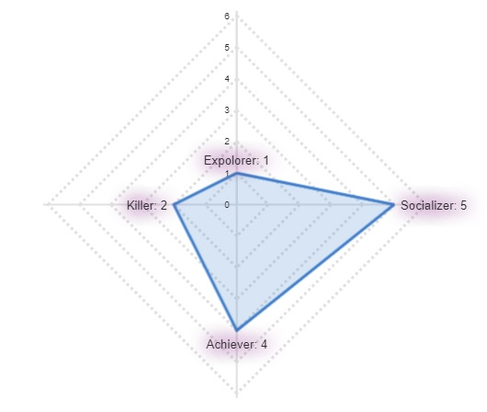

* **Socializer (5/5)**
  + Socializers will be able to collaborate with friends to reach a common goal, create new friendship, form groups, and communicate with each other.
* **Achiever (4/5)**
  + Achievers will be able to test their skill and improve themselves by completing faster and better each dungeon or the arena.
* **Killer (2/5)**
  + Killers will be able to show off and prevail over the other by completing in the fastest way possible the Carian Cave, competing in a speed run.
* **Explorer (1/5)**
  + Explorers will find few interesting rooms to explore and some lore pieces to connect in order to rebuild the backstory of each dungeon.

### Level of Expertise

“Let Me R.I.P.” is a game suited for hardcore gamers or at least for people who have played at least 2 other Action RPG games. The feature that makes this game difficult and hostile for new commers are: its fast-paced gameplay, its spirit gauge absorption mechanics that will not allow the player to perform strong abilities or transformation unless he was able to defeat a considerable amount of enemies, and its large amount of skill shots that will be hard to hit for casual gamers.

As for the hardcore gamers this game should test their skills, forcing them to hit skill shots, making the resource management hard and forcing them to collaborate in order to maximize the damage output and protect players that are in a more vulnerable position.

### Demographics

As it is shown in this graph regarding the United States, published by Statista (a statistical portal for market data), more than 50% of the total gamers is contained in the area between underage and 34 years old.

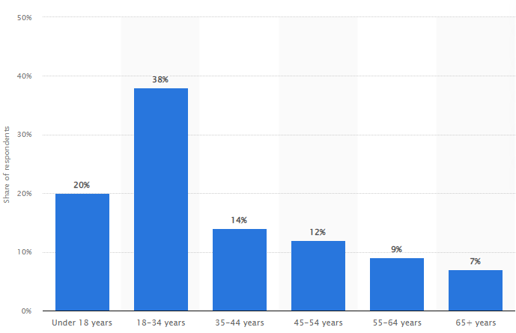

**[Distribution of video gamers in the United States in 2021, by age group** [**https://www.statista.com/statistics/189582/age-of-****us-video-game-players/**](https://www.statista.com/statistics/189582/age-of-us-video-game-players/)**]**

As is it shown in this article, human brain reaction time on average has a pick at 24-year-old and then starts a slow but steady decline <https://journals.plos.org/plosone/article?id=10.1371/journal.pone.0094215>.

Since our game has a fast-\paced gameplay and keeping in consideration the player’s distribution based on age, we expect our audience to be as follows:

|  |  |  |  |  |
| --- | --- | --- | --- | --- |
| Age | 10-18 | 19-30 | 31-45 | 46-65 |
| Distribution | **30%** | **45%** | **20%** | **5%** |

### Gender Distribution

As the graph published on Statista.com shows the gender distribution of female gamers, located in the US from 20067 to 2021, is barely under the 50%, depending on the specific year.

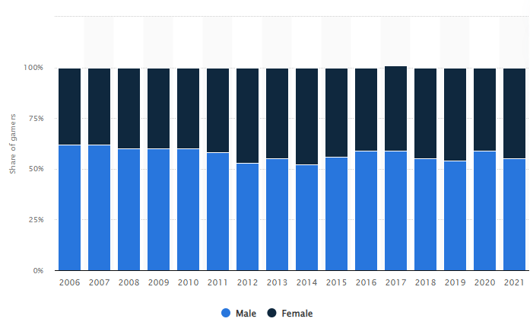

**[Distribution of video gamers in the United States from 2006 to 2021, by gender** [**https://www.statista.com/statistics/232383/gender-split-of-us-computer-and-video-gamers/**](https://www.statista.com/statistics/232383/gender-split-of-us-computer-and-video-gamers/)**]**

Even though the gender distribution among all genre of video games tent to be equals, there are strong genre specific differences as it shown in the graph reported by GameDeveloper.com intitled “Beyond 50/50: Breaking down the percentage of Female Gamers by Genre” <https://www.gamedeveloper.com/business/beyond-50-50-breaking-down-the-percentage-of-female-gamers-by-genre>:

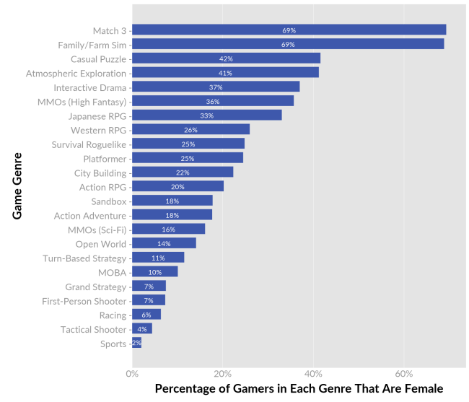

Especially the genre Action RPG, characterized by titles like Diablo III, Dark Souls III, Torchlight (series), the percentage of female players is 20%. The percentage grows a bit if we look at the Western RPG genre: Mass Effect 3, Dragon Age: Inquisition, The Witcher 3: Wild Hunt, Fallout 4, The Elder Scrolls: Skyrim, where female players represent the 26% of the players.

From this Graph is also clear that female players represent a large portion of the player’s population in more casual game genre like match 3 games, Family/Farm Sims games, Casual Puzzles and Interactive Drama.

From these considerations, we expect considerable number of our players to be male.

### Geographic Distribution

Let me R.I.P. will be entirely in English to facilitate a larger distribution. Even though the story will be narrated mainly by NPCs inside the game and by written text, it would also be possible to understand the context by the game environment, also allowing non-English speaking people to have a grasp on the story.

## PLATFORM

The game will be available on Steam for every major desktop platform.

Hardcore players, our target audience, mostly spend their time on PC and Consoles, but since we want to have a certain degree of sociality on our game by having a chat in it, it will be easier for the player to type with a keyboard rather than using a controller. However, we’ll still allow the player to play using a controller, if they wish to do so.

We are also not opting to develop on mobile systems since the game will require a significant number of inputs from the player, making it more suited for a keyboard rather than a mobile platform.

## SYSTEM REQUIREMENTS

For a complete breakdown of the system requirements, refer to Chapter 3 of the Technical Design Document.

## TOP PERFORMERS

### Children of Morta

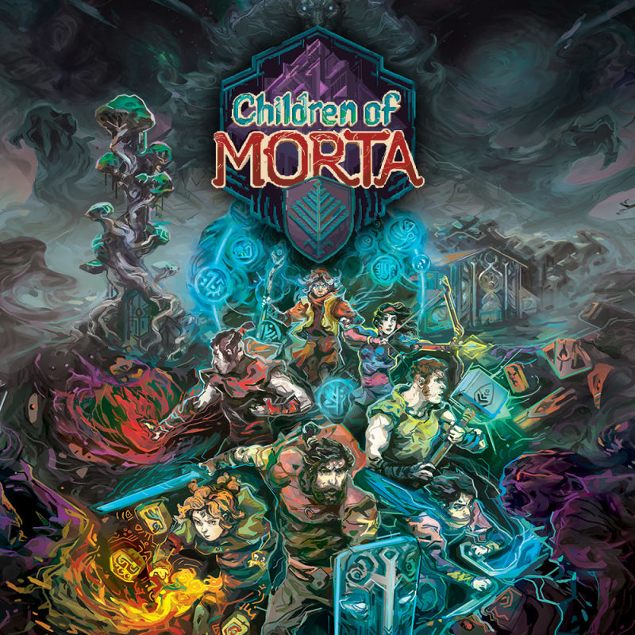

**Developer**: Dead Mage

**Platforms**: Windows, macOS, Linux, PlayStation 4/5, Xbox One, Xbox Series X/S

**Release**: 3rd September 2019 (Windows Version)

**Logline**: “Explore the depths of house Bergson' and discover what caused the corruption playing as different family members”

**Description:**

Children of Morta is a hack & slash action role-playing game, with roguelike elements. It follows the story of the Bergson family, custodians of Mount Morta, who must defend it from an evil called Corruption.

The player takes on the role of the members of the Bergson family, with additional family members being unlocked as the player progresses through the game, to a total of seven playable characters. Each of the family members has its playstyle, and gameplay mechanics and levels up independently.

The player must traverse several different dungeons within the caverns of Mount Morta to clear them of various enemies and bosses. At the end of each dungeon, a progression in the narrative may happen. Some parts of the story take place after specific events happening in the game.

Although the game can be played completely single-player, both local-coop and online coop are available to play with friends and fight corruption together.

### Diablo 3

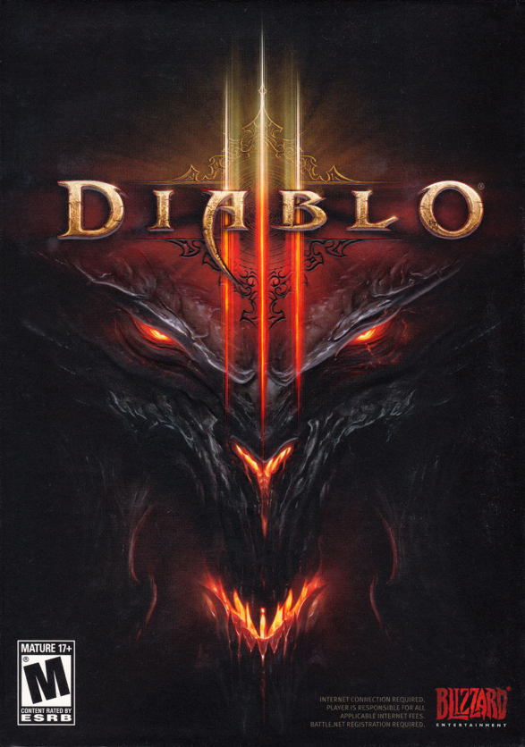

**Developer**: Blizzard Entertainment

**Platforms**: Windows, macOS, PlayStation 3/4/5, Xbox 360, Xbox One, Xbox Series X/S

**Release Date**: 15th May 2012 (Windows and macOS)

**Logline**: “Slay hordes of monsters and defeat the Dark Wanderer/Diablo”

**Description**:

Diablo 3 is a hack & slash action role-playing game. The story takes place in Sanctuary, the dark fantasy world of the whole Diablo Series.

Twenty years after *Diablo II*, the forces of Hell return to plague the world of Sanctuary. The hero of *Diablo III*  – a Barbarian, Monk, Wizard, Witch Doctor, Crusader, Necromancer, or Demon Hunter – must tap into their Nephalem heritage to surpass the Angels of Heaven,  apathetic to humanity's plight, and foil the schemes of Diablo, who plots to resurrect themselves into a form powerful enough to overthrow the celestial realms themselves. However, the ending of *Diablo III*hints that a truce or even cooperation may be possible between the angels and the humans, and this is something that the Lord Of Terror surely would be against.

The game can be played alone or in multiplayer. Up to three friends can dive into the PvM aspects of the game together, whereas the PvP Arena allows up to 6 players to fight each other in 3-player teams. There are also other scenarios in which a larger number of players can play and interact.

### Magicka 2

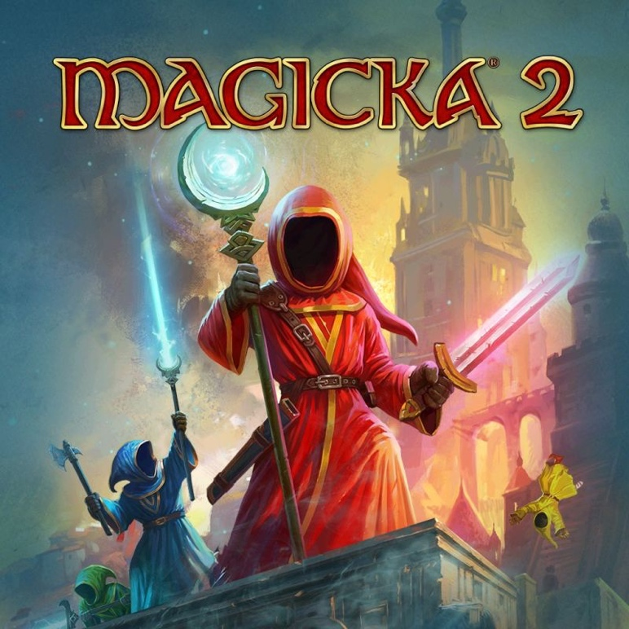

**Developer**: Pieces Interactive

**Platforms**: Windows, macOS, Linux, PlayStation 4/5

**Release Date**: 26th May 2015

**Logline**: “Traverse Midgard with a dynamic spell system to slay friends and foes”

**Description**:

Magicka 2 is a co-op action-adventure game, the sequel to Magicka.

In this chapter of Magicka, players ascend from the ruins of Aldrheim to experience a Midgård almost wiped free of Wizards after the Wizard Wars, with the few that do remain to have either gone mad or extremely hostile toward all others.

To rid the world of evil, again, up to four Wizards, and their guide Vlad will traverse Midgård armed with the next iteration of the famous Magicka dynamic spellcasting system, as players reprise their roles as the most overpowered, unpredictably funny Wizards ever known to fantasy!

### Monster Hunter: World

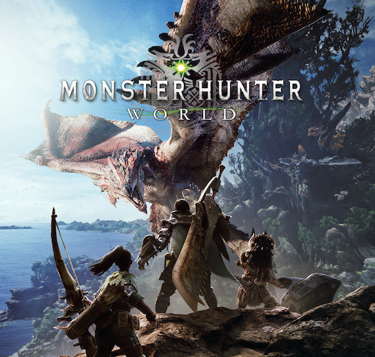

**Developer**: Capcom

**Platforms**: Windows, PlayStation 4/5, Xbox One, Xbox Series X/S

**Release Date**: 26th January 2018 (PlayStation and Xbox), 9th August 2018 (Windows)

**Logline**: “Haunt ferocious monsters in a variety of environments to craft stronger equipment to hunt even more dangerous monsters”

**Description**:

Monster Hunter: World is an action role-playing game and the fifth mainline installment in the Monster Hunter series.

In the game, the player takes the role of a Hunter, tasked to hunt down and either trap or kill monsters that roam in one of several environmental spaces.  If successful, the player is rewarded through loot consisting of parts from the monster and other elements that are used to craft weapons and armor, amongst other equipment. The game's core loop has the player crafting appropriate gear to be able to hunt down more difficult monsters, which in turn provide parts that lead to more powerful gear.   
Players may hunt alone or in a group of up to four players via the game's online multiplayer.

### Hades

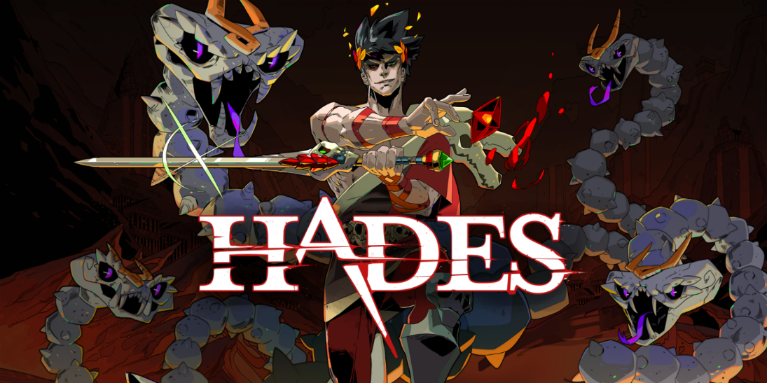

**Platforms**: Nintendo Switch, PlayStation 4, PlayStation 5, Xbox One, Mac OS, Windows, Xbox Series X/S

**Release Date**: 17th September 2020 (MacOS, Windows, Nintendo Switch), 13th August 2021 (PlayStation 4/5, Xbox One/XS)

**Logline**: “Defy the god of the dead as you hack and slash out of the Underworld in this rogue-like dungeon crawler from the creators of Bastion, Transistor, and Pyre.”

**Description**:

You play as Zagreus, immortal son of Hades, on his quest to escape from the underworld, fighting through many angry lost souls along the way. Death is a mere inconvenience for Zagreus, returning to Hades' palace each time to reflect in the Mirror of Night and try again. Receive Boons from the other gods of Olympus and find treasures to aid in each escape attempt.

### Dead Cells

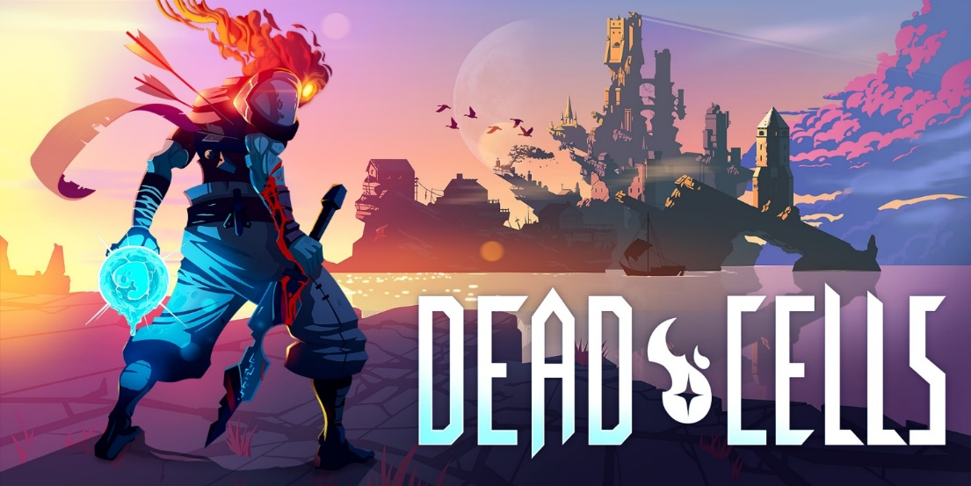

**Platforms**: Windows, macOS, Linux, Nintendo Switch, PlayStation 4, Xbox One, iOS, Android

**Release Date**: 7th August 2018 (Windows, macOS, Linux, Nintendo Switch, PlayStation 4, Xbox One), 28th August 2019 (iOS), 3rd June 2020 (Android)

**Logline**: “Dead Cells is a rogue-lite, Metroid Vania inspired, action-platformer. You'll explore a sprawling, ever-changing castle... assuming you’re able to fight your way past its keepers in 2D souls-lite combat. No checkpoints. Kill, die, learn, repeat.”

**Description**:

In the game, the player takes the role of an amorphous creature called the Prisoner. As the Prisoner, the player must fight their way out of a diseased island in order to slay the island's King. The player gains various weapons, treasure and other tools through exploration of the procedurally-generated levels, using them to fight various mutated creatures. At times, the player gains "Cells", an in-game currency that can be used to purchase permanent upgrades or unlock items. Dead Cells uses a permadeath system, causing the player to lose all Cells and other currencies and items upon each instance of death.

## FEATURE COMPARISON

|  |  |  |  |  |  |  |  |
| --- | --- | --- | --- | --- | --- | --- | --- |
| Feature | Hades | Dead Cells | Children of Morta | Diablo 3 | Magicka 2 | Monster Hunter: World | Let me RIP |
| Genre | RPG-Action, Rogue-like | Rogue-like, Metroidvania | RPG-Action, Rogue-like | RPG-Action, Hack and Slash | Action-Adventure | RPG-Action | RPG-Action |
| Platform | Nintendo Switch, PlayStation 4, PlayStation 5, Xbox One, Mac OS, Windows, Xbox Series X/S | Windows, macOS, Linux, Nintendo Switch, PlayStation 4, Xbox One, iOS, Android | Windows, Playstation 4, Xbox One, Nintendo Switch | Windows, Mac OS, Playstation 3 / 4, Xbox 360 / One, Nintendo Switch | Windows, Mac OS, Linux, Playstation 4, | Windows, Playstation 4, Xbox One | Windows, Mac OS |
| Number of Players | 1 | 1 | 2 | 4 | 4 | 4 | 3 |
| Bartle Types | Achiever,Killer | Achiever, Killer | Achiever, Explorer | Achiever, Killer | Socializer | Achiever, Socializer | Socializer, Achiever |
| Single-Player Mode | Yes | Yes | Yes | Yes | Yes | Yes | Yes |
| Controls | Keyboard, Controller | Keyboard, Controller | Keyboard, Controller | Keyboard, Controller | Keyboard, Controller | Keyboard, Controller | Keyboard,Controller |
| Shop/Microtransactions | No | No | No | Yes | No | Yes | Yes |
| Setting | Fantasy | Fantasy | Fantasy | Dark-Fantasy | Fantasy | Fantasy | Fantasy |

## PERSONAS

|  |  |
| --- | --- |
| Enrico | |
| Quick facts:  *Location: Milan, Italy*  *Occupation: Student*  *Age: 19*  Goal:  He wants a high-octane game where he can challenge his skills and collaborate with his university friends. | Studente bello sicuro che tiene libri e sorride alla macchina fotografica, librerie della biblioteca su priorità bassa, concetto di apprendimento e educazione |
| Videogame Knowledge  He has played 10/15 games since childhood and now has a lot of time to spent for playing. |
| Bartel’s Type  Killer, Socializer |
| Platforms  PC, PS4, Smartphone |
| Description | An Italian university student who mainly plays RPGs and Multiplayer games, in particular the ones that has a challenging and fast gameplay.  To play those games at best he owns a gaming pc, which he keeps up to date with the latest versions of hardware on the market. |

|  |  |
| --- | --- |
| Juan | |
| Quick facts:  *Location: Madrid, Spain*  *Occupation: YouTuber, Content Creator*  *Age: 27*  Goal:  He is looking for a new indie game where he can show off his abilities and skills but being able to play and cooperate with friends and other YouTubers in order to creates many videos. | Giovane blogger barbuto hipster in posa sullo sfondo bianco. Isolato Archivio Fotografico |
| Videogame Knowledge  He has played 30/40 games since he was a child. Now he has plenty of time for playing. |
| Bartel’s Type  Socializer, Killer |
| Platforms  PC, Xbox series S, PS4, Switch, Smartphone |
| Description | A Spanish Youtuber how has transformed his passion of playing and sharing games into his profession.  His PC is a gaming computer with the latest version of hardware on the market.  He is proud of his YouTube channel because he was able to reach important subscriber numbers by playing indie games. |

|  |  |
| --- | --- |
| Sharon | |
| Quick facts:  *Location: Seattle, USA*  *Occupation: Game Artist*  *Age: 22*  Goal:  She wants a game that she can play with her friends but with a fast and flashy gameplay. | Giovane architetto femminile con tavoletta grafica mentre si lavora con il computer |
| Videogame Knowledge  She has played 15/20 games since childhood and now she wants to spend her free time, playing games with her friends. |
| Bartel’s Type  Socializer, Achiever |
| Platforms  PC, Switch, Smartphone |
| Description | An American game artist. After completing her collage studies, she was able to get a job as artist in a small-mid size studio in Seattle, where she moved.  He has a high-end laptop that she has chosen to buy to meet her passion but still being able to move and travel without too many constraints. |

# LEGAL ANALYSIS

Every asset used in this game is regularly acquired from the Unity Asset Store, aside for music and a few models, that will be commissioned to third party components.

All licenses needed to use these assets for commercial purposes will be acquired if necessary.

This game is expected to be PEGI 12, due to mild violence and references to death of fantasy characters.

# GAMEPLAY

## OVERVIEW

Our core mechanics work around a dynamic resource management, the Spirit Gauge, used to cast abilities and transform, a character swap mechanic where we see the player switching from a spirit form to a physical form to a more powerful physical form and back.  
The combat mechanics are based on abilities, these are divided into 2 special abilities and 2 basic ones (light and heavy attack), in addition to this, 2 transformations are available per class.  
A transformation is characterized by a swap of abilities to more powerful ones but also more expensive to cast.

## CORE MECHANICS

### Resources

HP (Hit Points)

Points indicating the remaining health of a character. They can be depleted by enemy attacks.  
HP can be regained in multiple ways (e.g., mage’s healing spells, consumables)

Souls

Used as a currency, souls can be obtained by defeating enemies. Every type of enemy gives a different amount of souls as reward.

Spirit Gauge

The container of spirit points (SP). Each spirit point fills the gauge with 1 unit.

All enemies have a pool of spirit points that can be depleted; it becomes available only after the enemy has been defeated. If the player does not interact with the pool it will disappear after a little while.

The process of depleting a pool of spirit takes some time. This process is interrupted if the player moves or receives damage, in this case the player keeps the retrieved spirit points so far, leaving the remaining for a later interaction until there are no more spirit points left in the pool.

Gold

The currency used to purchase items from the market.  
Obtained by slaying enemies or by reselling bodies back to Schrodinger (40% of the original price)

AC (Awesome Coins)

The currency is used to purchase special unique items and services from the market.   
Can only be obtained through microtransactions.

### The Spirit Form

The default form of the character controlled by the player.

The spirit has a level that can be increased by gaining experience, obtained by defeating enemies. The level of a spirit determines its statistics, and its statistics reflect its overall performance.

At the start of the game, the spirit form has 50 HP and 30 Mana. These values can be increased through leveling.

The abilities available, while in this form, are class-independent and are detailed in the [Abilities] section.

**Dying**

If the players lose all its HP, it will be forcefully dragged out of the dungeon by a Sally’s spell.

### The Physical Form

The player can change into physical form by obtaining a body.

#### Bodies

An old vessel of life.

Each body belongs to a specific class and can only be used by a character of the matching class. Although one character may use only one body at a time, they can own multiple.

Each body has a rarity, a level, and a set of statistics:

* Its rarity is completely random.
* Its level will be a random value in the range +- 5 levels of the player that visits the shop.
* Its statistics are random values that depend on the rarity and level.

With the body also comes a description that gives hints about the previous owner’s life (e.g., a letter on one of the pockets, a brooch/ring/necklace with a famous family symbol, a weird-looking stain or smell).

Level

The current level of a body determines the minimum level the player must be to use it.

All the bodies can be leveled up by visiting Milly.

A body can be leveled up, up to 5 times, making it reach its best form. A body cannot have a level higher than the spirit.

Rarity

A body has one of the following rarities:

* Rotten (rarity -1)
* Undamaged (rarity 0)
* Good looking (rarity 1)
* Perfect shape (rarity 2)
* Chad (rarity 3)

Each rarity defines a range for each statistic. When a body is leveled up the stats gained will be a value between the two ends of the range. The higher the rarity, the higher the two ends will be.

Obtaining a Body

A body can be found in the game world, obtained as a reward, or bought from Schrodinger's shop.

Cost in Spirit Points (SP)

To take over a body the player will need to infuse it with several SP. The number of SP needed depends on the level and rarity of the body itself.

The player can take over a new body or reuse an old one by visiting Milly. Reusing an old body requires an infusion with the same number of SP that were required the first time.

Tether

When a body is taken over, a tether between the spirit and the body is created. Only one tether can exist at the same time, meaning the player can only use one body at a time.

The tether can wear off over time, the bigger the wear, the smaller the bonus stats the body grants. If the tether wears off completely the player will not be able to use the body anymore, meaning it will have to be re-tethered. The transition between physical and spirit form can happen at any time at no cost.

Additional HP bar

Each body has its own HP bar.   
While the player is using the body, its HP will be used instead of the spirit’s.

Once the HP of the body hit 0, the body will drop on the ground and will not be usable anymore, leaving the player in Spirit form. The body can be reobtained through the player’s Schrodinger’s services. Every time the HP of the body hits 0, the tether is damaged by 15%.

Transformations

Only while in physical form, the player will be able to access the transformations for their specific class, if they have been unlocked.

To be able to transform the player must have at least 60% of their spirit gauge filled.  
When transformed every ability (both basic and special) will consume SP.  
When the spirit gauge is completely depleted the transformation will drop, making the player return to its normal physical form.

If an ability would deplete completely the spirit gauge, it can still be casted, depleting the spirit gauge, and ignoring the remaining cost.

If the player loses the transformation’s hit points then he will lose the body as before, and the spirit gauge will remain untouched until further use. If he is later able to regain the body, it will not be transformed but in its normal physical form.

Additional Stats

While in physical form, the player will use the statistics and effects of the wore body.

### Leveling

Two things can level up: the spirit and the body.

The spirit levels up by gaining experience points which are obtained by defeating enemies.  
The amount of experience needed to level up the spirit will increase at every level.  
Every type of enemy will grant a different amount of experience after being defeated.

A body instead, will need to undergo a special “procedure” by Milly. Such a procedure will have a cost in Souls and cannot be performed more than five times on a single body.  
The required number of Souls to level up a body is strictly dependent on the current level of the body and its rarity, the higher they are, the higher the price.

### Classes & Transformations

The player can choose between one of three classes: the warrior, the mage, and the archer.

Each class has two transformations available that can be used by the player at any time once they have been unlocked.

Warrior

The warrior is a melee class that uses a single-handed sword to attack. The warrior can only be male.

His available transformations are:

* **Berserker**: he uses a big two-handed sword to slash enemies. He specializes in inflicting massive amounts of damage to many enemies at the time.
* **Paladin:** he uses a single-handed sword and a magical shield. The magic in the shield increases the paladin’s defense and elusion while also enhancing the power of his sword, allowing for stronger focus attacks.

Mage

The mage is a ranged class that uses a scepter to cast abilities. The mage class is available for both sexes.

The available transformations are:

* **Warlock**: the mage that gave into darkness. They can cast brutal abilities to murder enemies or drain their life force. Their attacks are strong and focus on single targets.
* **Cleric**: the mage that followed the light. They can create explosions of white magic to injure enemies and debilitate them while healing their surrounding allies.

Archer

Archer is a ranged class that uses a bow and arrow to shoot enemies. The archer can only be a female.

The available transformations are:

* **Huntress**: she relies on the power of a crossbow to deliver rapid and focused attacks from a distance. She can also summon a pet to help her in combat.
* **Cannoneer**: she can make cannonballs rain using her powerful magical cannon. Through this weapon, she can harness the power of fire to bring hell upon her enemies.

**Spirit form**

Its key role is retrieving spirit gauge for the physical form and protecting the body while performing this action.

### Abilities

|  |  |  |
| --- | --- | --- |
|  | Description | Cooldown & Cost |
| Space – Dash | Performs a forward dash | 2.3 sec  0 SP |
| Ctrl – Enter/Exit body | if performed while in spiritual form, sends the spirit to the body; If performed while controlling a body it expels the spirit from it. |  |
| Shift + Q – Transformation 1 | Takes the first form.It can only be performed if controlling the physical body. |  |
| Shift + E – Transformation 2 | Takes the second form. It can only be performed if controlling the physical body. |  |

#### Spirit

|  |  |  |
| --- | --- | --- |
| Ability | Description | Cooldown & Cost |
| Light attack | Fires a medium-sized projectile of spiritual energy that travels for a short-medium distance, dealing a **(6+0.1*INT)** damage to every enemy hit. | 0.80 sec  0 SP |
| Heavy attack | Charges spiritual energy and after **(1.5)** seconds releases a large cone-shaped wave dealing **(15+0.2*INT+o.1*STR)** damage and stuns for a small duration **(0,3)** second. | 4.00 sec  0 SP |
| E | If performed near a defeated enemy, you can regain spirit gauge by nourishing on his soul. During this action, the player is slowed by **(0.75*Swiftness)**. | 1.00 sec  0 SP |
| Q | Releases some Spirit power dealing **(10+0.3*INT)** damage and stunning enemies for **(1.5)** seconds. |  |

#### Warrior

##### Basic Warrior

|  |  |  |
| --- | --- | --- |
| Ability | Description | CD & Cost |
| Light attack | swings his sword single-handedly, dealing **(10+0.1*STR+0.1*DEX)** damage to the first enemy in front of him | 0.86 sec  0 SP |
| Heavy attack | performs a lunge attack, thrusting his sword forward dealing **(15+0.4*STR)**. It results in a dash that ends after a set distance piercing every encountered enemy, eventually stopping on the first encountered obstacle (walls, fences, etc.). | 1.50 sec  0 SP |
| E | Horizontal slash that deals damage **(10+0.4*STR)** in a cone-shaped way in front of the player. Every enemy hit grants the player **(20+0.3*STR+0.2*INT)** temporary hit points up to 4 enemies. This extra hit points gradually decay in **(4)** seconds. | 1. sec   o SP |
| Q | Performs a scream hitting every enemy in a cone in front of him, dealing **(2+0.3*STR)** damage, stunning close enemies and slowing the further ones. | 5.0 sec  15 SP |

##### Paladin

|  |  |  |
| --- | --- | --- |
| Ability | Description | Cooldown & Cost |
| Light attack | Quickly slashes the sword in front of him, hitting the closest enemy dealing **(10+0.2*STR+0.1*INT)**. If performed after a successful block (within 1 second after the block), it deals extra damage **(LightAttack+0.3*STR)** in a small area. | 0.80 sec  3.2 SP |
| Heavy attack – Defensive stance | He raises his shield to block incoming attacks, if the shield successfully blocks an attack allows the player to perform a counterattack. The shield has **(40+1*STR)** HP that will decay over time. After reaching 0 hp a cooldown starts, while in cooldown the shield’s hp are regenerated. | 0.80 sec  3.2 SP |
| E – Shield bash | Performs a dash in front of him with the shield up, the first enemy or wall encountered causes the shield to deal damage **(10+0.1*STR+0.1*DEX+0.1*INT)** and emit a bright light, stunning for **(2 sec)** every enemy within range. | 5.00 sec  20 SP |
| Q – Landing swords | Summons three swords lined in front of him that will fall on the terrain one after the other dealing damage **(25+0.3*INT)** to the enemies within range. | 9.00 sec  36 SP |

##### Berserker

|  |  |  |
| --- | --- | --- |
| Ability | Description | Cooldown & Cost |
| Light attack | Vertical Slash dealing **(10+0.35*STR+0.1*DEX)** | 0.80 sec  3,2 SP |
| Heavy attack – Quick spin | charges for 1-2 seconds, on release it quickly spins twice hitting every enemy within range dealing **(15+0.3*DEX+0.3*STR)** for each hit. If enraged no charge is needed. | 4.00 sec  16 SP |
| E – Rage | Consumes his defense **(-0.33*Defense)** to enhance his Strength **(0.2*STR)** and reduce all his cooldowns **(CD*(1-0.3)).** Rage will persist for 8 sec. | 9.00 sec  36 SP |
| Q – Leap Earthquake | Leaps in the air, landing in a specified area causing the earth to tremble, every enemy within range takes damage **(40+0.7*STR)** and it is slowed by **(Swiftness*(1-0.3))** for **(2 sec)**. | 10.00 sec  40 SP |

Storyboard – Leap Earthquake

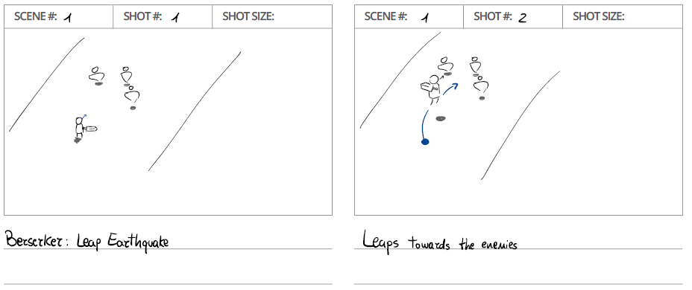

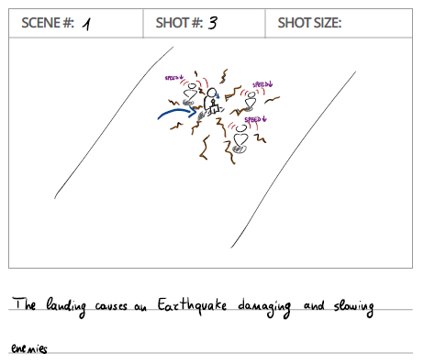

#### Mage

##### Basic Mage

|  |  |  |
| --- | --- | --- |
| Ability | Description | Cooldown & Cost |
| Light attack | fires a single target magic sphere that deals **(10+0.2*INT)** damage upon impact. | 1.20 sec  0 SP |
| Heavy attack | charges up to 1-2 seconds and releases a storm of magic spheres that deal **(15+0.3*INT+0.1*DEX)** damage on their way passing through enemies. | 3.00 sec  0 SP |
| E | Charge and release a single target instant beam dealing **(15 +0.1*INT+0.1*STR)** up to **(35+0.3*INT+0.2*STR)** damage depending on how much the beam has been charged. | 5.00 sec  0 SP |
| Q | A healing area is summoned at the caster’s position. This ability will consume mana/spirit gauge over time slowly restoring hit points of every player (caster included) up to **(50+0.4*INT)** in **(4)** seconds. | 7.00 sec  15 SP |

##### Warlock

|  |  |  |
| --- | --- | --- |
| Ability | Description | Cooldown & Cost |
| Light attack | fires a small black sphere that deals damage **(20+0.4*INT)** on impact and **(0.1*INT)** damage in a small area. | 1.00 sec  7 SP |
| Heavy attack | Casts a beam of black magic with a limited range. It inflicts small damage but with a high attack rate, **(20+0.3*INT+0.2*STR per second)** per second, part of the damage is converted to **(0.05*max HP)** HP per second. While casting his swiftness is reduced by **(Swiftness * 0.5)**. | 0.1 sec  30 SP per second |
| E | Stabs himself, taking **(max HP*0.15)** damage and recovering **(max Spirit Points*0.15)** spirit points. | 0.2 sec  0 SP |
| Q – Death sphere | Casts a big black sphere. This sphere does not deal damage upon hitting enemies but if it is hit by an attack or ability of the caster or other players, it explodes dealing **(40+0.7*INT+0.3*STR)** AOE damage pulling enemies into the center of the explosion. | 9.00 sec  62 SP |

Storyboard – Death sphere

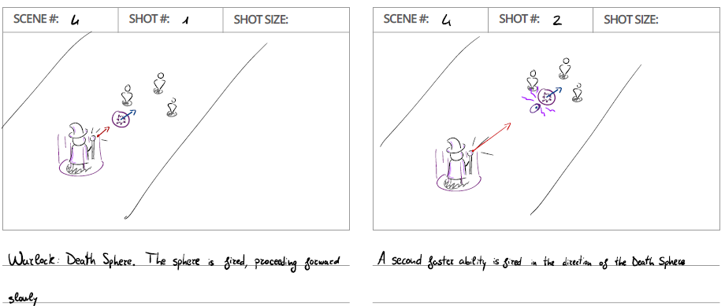

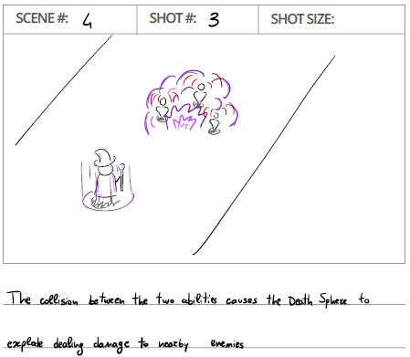

##### Cleric

|  |  |  |
| --- | --- | --- |
| Ability | Description | Cooldown & Cost |
| Light attack | fires small light spheres dealing **(15+0.3*INT)** damage to a single enemy and slightly reducing its defenses **(Defense*0.1)**. The weakened enemy is marked by a bright light above their head. | 1.00 sec  4 SP |
| Heavy attack | Summons a hammer of light, which can be charged for 2,5 seconds and when released hits the ground dealing **(15+0.2*INT+0.1*STR)** up to **(40+0.3*INT+0.3*STR)** AOE damage, the longer you charge it, the higher the damage and the bigger is the area of impact. | 3.50 sec  14 SP |
| E | Summons a pool of life at a specified location for **(4.5 sec)**, it can be charged up to 3 seconds, the longer you charge it the higher is the amount of life recovered from **(35+0.4*INT)** up to **(50+0.8*INT)** and the bigger the pool becomes from a radius of **(3)** to **(7)**. | 9.00 sec  36 SP |
| Q – Beacon of Hope | Summons a Cross of Light at a specified location, every enemy near the cross takes **(30+0.3*INT)** damage upon summoning and after that **(10+0.2*INT)** damage per second for **(5)** seconds. Every ally that stays near the cross gains a buff: **+0.1*STR, +0.1*DEX, +0.1*INT, +0.15*Defense** until inside the area of effect and for **(3)** more secondsafter exiting**.** | 12.00 sec  48 SP |

Storyboard – Beacon of Hope

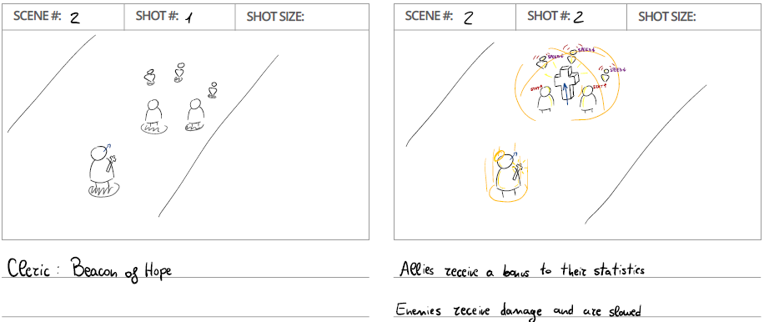

#### Archer

##### Basic Archer

|  |  |  |
| --- | --- | --- |
| Ability | Description | Cooldown & Cost |
| Light attack | Fires an arrow straight in front of him dealing **(10+0.2*DEX)** damage on the first enemy struck. | 0.86 sec  0 SP |
| Heavy attack | Throws a curving arrow dealing **(15+0.3*DEX+0.1*INT)** damage. | 4 sec  0 SP |
| E | Fires 4 arrows in a rapid succession in a straight line dealing **(30+0.4*DEX)** total damage | 5.00 sec  0 SP |
| Q | Throws 5 arrows at the same time with different angles dealing **(10+0.25*DEX)** damage for each arrow. | 6.00 sec  15 SP |

##### Huntress

|  |  |  |
| --- | --- | --- |
| Ability | Description | Cooldown & Cost |
| Light attack | Fires a dart dealing **(15+0.4*DEX)** to the first enemy struck. | 0.80 sec  3.2 SP |
| Heavy attack | Fires a dart that pierces through enemies and structures, the more obstacles you hit the higher the damage. The dart itself deals **(25+0.3*DEX)** and every obstacle and enemy pierced grants an extra **(10+0.2*DEX)** damage to the next hit creature. | 3.50 sec  14 SP |
| E | Conjures a Bear. If the Bear is already summoned, she commands it to move and attack to a specified location. | 1.00 sec  45 SP upon summon  0 SP when summoned |
| Q | Shoot a Drill Dart dealing **(30+0.35*DEX+0.2*STR)**, this dart stays on the enemy body for **(3.5)** seconds, this dart can be hit by simple darts. When a simple dart hits the Drill Dart stuck in the enemy body, in addition to simple dart damage, it also slows the enemy for **(0.5)** seconds. At the third simple dart, the enemy will receive the damage of Drill Dart a second time and it will get pushed back from the caster, if the enemy hits a wall, it will get stunned for **(1 sec)**, double Drill Dart damage, reduce Drill Dart cooldown **(50%)**. Bosses cannot be pushed back and stunned but they will still receive the extra damage from the third hit. | 10.00 sec  40 SP |

|  |  |  |
| --- | --- | --- |
| Bear | Description | Cooldown & Cost |
| Light attack – Bite | Deals **(15+0.1*STR)** damage to a single target in front of it. | 1.33 sec  0 SP |
| Heavy attack – Claw | Deals **(20+0.2*STR+0.1*DEX)** damage to a wide (although short) area in front of it. | 11 sec  0 SP |

##### Cannoneer

|  |  |  |
| --- | --- | --- |
| Ability | Description | Cooldown & Cost |
| Light attack | Fires a cannonball that deals damage **(20+0.2*DEX+0.2*STR)** on impact and **(0.2*STR)** damage in a small area. | 1.20 sec  4.8 SP |
| Heavy attack | Fires 2 Chained cannonballs in a forward line dealing **(20+0.3*DEX+0.2*STR)** AOE damage to every enemy on their way. | 1.20 sec  4.8 SP |
| E | Shoot an explosive in the air, after **(.75)** seconds it will fall causing an explosion dealing **(15+0.3*DEX+0.2*STR)** AOE damage. | 7.00 sec  28 SP |
| Q – Hot shot | Heats a cannonball (holding Q) up to **(4 sec)**, the longer you hold it, the higher the temperature will rise, up to **(400°)**. If the ability is held for too much, rising the temperature from **(300°)** to **(400°)** the ability will explode causing everyone (caster included) to take **(50+0.45*STR+0.1*INT)** AOE damage. On release, it will shoot the cannonball. The hot cannonball will pass through enemies, setting everything on fire on its passage, until it hits an obstacle or up to **(15)**. The temperature will determine the damage of the cannonball. **(30+0.2*DEX+0.2*STR+0.1*temperature),** cannonball width **(0.5+0.01*temperature)**, the burn damage duration **(0.5+0.01*temperature)**, and the burn damage **(0.05*temperature) per second**. | 13.00 sec  52 SP |

Storyboard – Hot shot

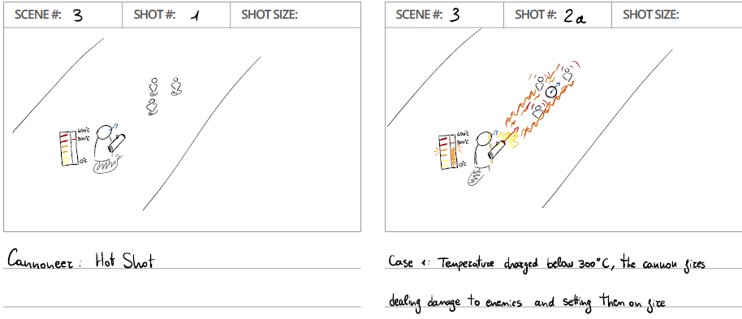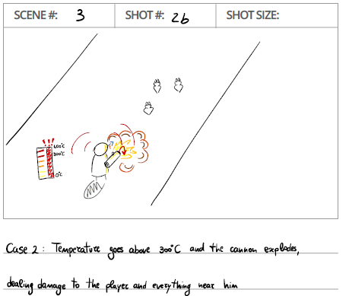

## PLAYER STATISTICS

Every in-game character (the spirit, bodies, enemies, etc.) shares the following statistics.

#### Offensive Stats

* **Strength (STR):** increase the effectiveness of strength-based abilities.
* **Intelligence (INT):** increase the effectiveness of magic-based abilities.
* **Dexterity (DEX):** increase the effectiveness of dexterity-based abilities.
* **Crit Chance:** the chance to strike a *critical hit* and deal more damage
* **Crit Damage:** percentage ofbonus damage of the *critical hit* over the base damage

*Total Attack Damage (non-critical) = Attack*  
*Total Attack Damage (critical) = Attack * (1 + Crit Damage / 100)*

#### Defensive Stats

* **HP:** the character’s hit points.
* **Defense:** the reduction in damage taken from an enemy’s attack.
  + 1 defense point will reduce by 1 point the damage taken from any attack
  + In any case, the damage taken cannot be less than 30% of the damage of the enemy’s attack
* **Agility:** the movement speed of the character.

## SHOPS

The player may purchase goods or services by exchanging Gold, Souls, or Awesome Coins (AC).

### The Smelly Corpse

*“That smell? Well dear, I sell corpses and I can assure you that once dead they don’t take baths anymore HOHOHO. I don’t mind it; it makes it easier for me to find my way home.”*

Shop driven by Schrodinger, an old mole, he sells dead bodies found in the catacombs, and other items that help the game progression such as elixirs.

The bodies and other items offered in the shop are refreshed occasionally. To refresh the shop’s offerings immediately the player may pay some AC (maximum 2 times per day).

#### Key items

Some bodies are not buried alone.

Schrodinger will occasionally sell items found with the corpses that will help the player on his journey, like maps and keys. Some of these items are optional, however, others may open new story paths.

**Pickup Service**

The purchase of the first body comes with a free pickup service: Schrodinger offers himself to pick up the body when left behind.

The pickup will occur when the body’s HP has been completely depleted.

The player may reobtain their body by talking to Schrodinger once they have died or have completed the dungeon where he has lost the body in.   
Schrodinger may also be found in healing rooms if their service is needed. In these scenarios, the player will have to pay a small fee to get their body back.  
The player will reobtain their body with 33% of its total HP.

A debuff will be applied to the body if the player regains it by reviving the body in such a way.  
This debuff reduces the player's overall statistics by 30% and will be removed only once the player gains a Y number of souls scaling with the body’s level.

Schrodinger’s services may also be explicitly requested up to two times per dungeon. This will only be available after X minutes the player has left the room where they lost their body, and while not currently in combat. (Paid feature)

Every call requires the use of a [Bell/Ring key object]; rare to find, but it can always be purchased with AC or a remarkably high amount of gold. While the AC cost is fixed, the amount of gold requested to buy such an item scale with the player’s level.  
When a body is revived in such a way it returns with 80% of its HP.

This way of regaining the body does not apply any kind of debuff.

### Milly the Tailor of Souls

*“First a tailor, then a necromancer’s right hand, and now unemployed, sometimes life can be unpredictable, huh?”*

She usually wanders around the dead hoping that someone needs her services.   
She came back to business in these very catacombs due to the enormous number of souls being brought back to life.

Tethering

She can tether a soul to a body or restore the health of the set tether, in exchange for Gold and Souls.

Leveling Up Bodies

Another service offered allows the player to level up their bodies in exchange of Souls. The cost depends on the level of the body it is trying to level up, the higher the level the higher the cost.

### Mercy

He sells body skins, consumables, and gold in exchange for AC.  
Also for a small payment, you can play a game of dice with him, if won the player will be awarded a prize.

**Changing the rarity of a body**

Mercy’s shop also offers the possibility to change the rarity of a body in exchange for AC. The amount of AC required increases depending on the initial rarity of the body.

The upgrade is not guaranteed: the higher the initial rarity, the lower the chance the upgrade will succeed

**Body skins**   
They change the appearance of the body, and some of them will also guarantee a small increase in statistics.  
Each skin is bound to a specific body once it has been activated.

**Dice games**  
If you bet a number of AC, mercy will play a game of Dice with you betting on a hidden prize, which can be a skin, a consumable, or a set of consumables.

The rules of the game are very easy: both the player and Calsifer will throw two six-sided dice, the one that will have the higher sum will win the match. In case of a tie, the dice will be rolled again until someone wins.

### Consumables

Different elixirs can be found across the catacombs.

An elixir can be seen as a container of a special effect, it is not always something drinkable, it may contain a healing liquid or a deadly poisonous gas.  
Every elixir has a cooldown between each use and a maximum amount of carriable elixirs of the same type, this limit differs from elixir to elixir.  
The player can have on him no more than 4 different types of elixir.  
Before using an elixir it must be selected; Once the selected elixir has been used its cooldown will start, and it will prevent any other elixir use, even of different types.

**Selection wheel**A wheel will be used to select an elixir.   
The wheel is divided into 4 sectors or slots, each one can contain one type of elixir. On every sector that contains a type of elixir is also displayed the remaining number of elixirs of that type.

When the player depletes a type of elixir the slot that used to contain it will be freed and it can be used to hold other types of elixir.

Two slots cannot contain the same type of elixir doubling its max carriable number.

**Collecting elixir in the Dungeons**Elixirs can also be found while exploring the catacombs.

If all 4 slots are full and the player tries to collect a fifth elixir, he will be asked to choose which one to discard, whatever the choice is, every elixir of the select type will be discarded to free a slot for the new one (or discarding the number of the newly found elixir).

**Fragile Elixirs**Special elixirs that can only be found in dungeons. Due to their fragile and unstable nature, once the player exits the dungeons every unused Fragile Elixir will break, removing it from the wheel and the Elixir Inventory

**Buying Elixirs**The Smelly Corpse and Mercy sell elixirs. The bought elixir will end up in the inventory.

**Elixir Inventory**The Elixir Inventory is storage for elixirs that the player can browse to select which ones to bring into the dungeons.

**Unused elixirs**  
After completing a dungeon, every non-Fragile Elixir unused will end up in the inventory.  
Fragile elixirs will be automatically destroyed.

**Potions**

|  |  |  |  |  |  |
| --- | --- | --- | --- | --- | --- |
| Name | Description | Cooldown | Usages | Is Fragile | Price |
| HP Potion | Instantly regenerates **(10-25-50)** amount of **hit points.** | 20 sec | 3 | No | 20 G |
| HP Over Time Potion | Regenerates amount of **hit points (30-50-80)** in **10** seconds | 15 sec | 2 | No | 40 G |
| Sleepy Heal Potion | Regenerates amount of **hit points (50-70-100)** in **5** seconds, during these **5** seconds the player will be **asleep**, enable to move or attack or use abilities. | 35 sec | 1 | No |  |
| SG Potion | Increase **Spirit Gauge** Absorption **(5% - 8% - 12%)** for **5** seconds. | 20 sec | 2 | No | 30 G |
| DEF Potion | Instantly increase **DEF** by **(10 – 15 – 20)** for **5** seconds. | 30 sec | 2 | No | 50 G |
| DEF Over Time Potion | Increase **DEF** over time **(1 point every second)** until you will be hit, in that case, you will lose all your **DEF** gained. | 25 sec | 1 | No | 50 G |
| Overheal Potion | Gain **(55-75-100)** hit points that will decay over time **(1 each second)** | 40 sec | 1 | No | 90 G |
| Vacuum Potion | **Imprison** a simple enemy **(Simple soldier, spiderling, minion)**. A second use, release a sphere that will hit a single target dealing the number of **hit points** of the imprisoned creature. | 19 sec | 3 | No | 35 G |
| Speedy Potion | Instantly increase Swiftness **(3% - 5% - 8%)** for **5** seconds | 22 | 3 | No | 40 G |
| Ice Potion | Throw the potion, on impact it will **freeze** any enemy, player, and surface in an area.  **Frozen creatures** will not move for **3** sec.  **Frozen surfaces** will cause creatures to **slide** without controlling direction until touching a non-frozen surface | 31 | 1 | No |  |
| STR Potion | Increases STR by **(10)**% but reduces INT and DEX by **(10)**% for **8** sec | 24 | 2 | No | 55 G |
| STR Potion+ | Increases STR by **(20)**% but reduces INT and DEX by **(15)**% for **5** sec | 19 | 1 | No | 110 G |
| DEX Potion | Increases DEX by **(10)**% but reduces INT and STR by **(10)**% for **8** sec | 24 | 2 | No | 55 G |
| DEX Potion+ | Increases DEX by **(20)**% but reduces STR and INT by **(15)**% for **5** sec | 19 | 1 | No | 110 G |
| INT Potion | Increases INT by **(10)**% but reduces STR and DEX by **(10)**% for **8** sec | 24 | 2 | No | 55 G |
| INT Potion+ | Increases INT by **(20)**% but reduces STR and DEX by **(15)**% for **5** sec | 19 | 1 | No | 110 G |
| Health shot | Increases Max HP by **15%** for **15** seconds. | 46 | 1 | No | 87 G |
| Decanter of Bats | Releases **(1-2-3)** swarms of bats that attacks a random creature. The life of the swarm of bats will decay over time. | 22 | 2 | No | 45 G |
| Chad | **Halves** your current HP, reduces your Defense to **0**, but increases INT, DEX and STR by **25%** for **10** seconds or until you get hit | 36 | 1 | Yes |  |
| Vampire | Consumes **20%** of your SG but grants **10%** life steal from LA and HA for **7** seconds | 35 | 2 | Yes |  |
| Smoke Field | Creates a smoke field on a specified location for **4** seconds. If the player stays inside the smoke field he cannot be targeted by enemies. | 30 | 2 | No | 65 G |
| Pot. Of Greed | If the room hides a treasure (eg. Survival rooms) reveals hit, but if not taken within 8 seconds it will be destroyed | 20 | 1 | Yes |  |
| Self-Pyro | Light yourself on fire for **8** sec causing taking (1,5)% damage every second but your LA and HA also light enemies on fire, dealing (0.01 * enemy max HP) damage per second for **3** sec | 20 | 2 | Yes |  |

## MULTIPLAYER EXPERIENCE

The following are the features that shape the game’s multiplayer experience.

### Chat

In every area of the game, a global chat will be available to allow the players to interact and coordinate, if necessary. Depending on the position of the player, the scope of the chat may be different.

### Friends System

A player can befriend any other player in the game. A friend request must be sent and accepted for the players to be added to each other’s friends list.

Once players have become friends, they will be able to message each other directly and privately through a dedicated chat.

In every scenario in which there are multiple players on the map, it is possible to befriend others.

### Invite Friends to Hub

One player can invite any of their friends to their hub.

Friends inside the same hub can collaborate on campaign dungeons. Up to 3 players can join the same campaign dungeon simultaneously, including the hub’s owner. A player can only join a campaign dungeon if they have either already completed it, or it is currently available for them to complete in their hub.

If a player completes a campaign dungeon in another player’s hub, it will also be marked as such in their hub.

### Stat balancing

In a multiplayer context it might happen that a more experienced player with high statistics joins one that hasn’t progressed as much.  
To compensate such difference, every dungeon will have a maximum amount of statistics.

For Crit chance, Crit damage, Defense and Swiftness there will be a flat max amount.  
To balance Strength, Dexterity and Intelligence we will proceed as follow:

Let M be an integer given for every dungeon and let S = STR+DEX+INT.  
The new values for Strength, Dexterity and Int will be multiplied by a factor of S/M.

Example:  
Let’s consider Body A as our starting body.

|  |  |
| --- | --- |
| Body A |  |
| STR | 1765 |
| DEX | 743 |
| INT | 445 |
| Defense | 238 |
| Crit chance | 25 |
| Crit Damage | 2 |
| Swiftness | 40 |

And our dungeon has the following max stats

|  |  |
| --- | --- |
| Dungeon A |  |
| M | 1000 |
| Defense | 215 |
| Crit chance | 1.5 |
| Crit Damage | 1 |
| Swiftness | 60 |

Then if a player with Body A equipped tries to enter Dungeon A then Body A will see its stats changed to the following for the rest of the dungeon:

|  |  |
| --- | --- |
| Body A |  |
| STR | 597 |
| DEX | 251 |
| INT | 150 |
| Defense | 215 |
| Crit chance | 1.5 |
| Crit Damage | 1 |
| Swiftness | 40 |

The cap imposed in each dungeon will let every player that reaches such stat to complete it with ease but not enough to ruin completely the experience of other players.

### Special Multiplayer Dungeons

Some special multiplayer dungeons are also available. They are available to join from the player’s hub but require multiple people to complete, meaning they cannot be accessed by a single player.

A player may join these dungeons with their friends or may do so with other players randomly selected from the ones interested (through matchmaking).

The number of players needed to play a special dungeon depends on the dungeon itself: a minimum and maximum or fixed number of players are provided.

### Balancing Dungeons’ Difficulty for multiple players

Almost every dungeon can be accessed by multiple players. To balance the difficulty of it, every room, except boss ones, will increase the number of enemies. In addition, some enemies will see their life increased.

### Dying

When a player dies when playing with friends, a tomb will spawn at his position with a bar on top of it.  
Other players can sacrifice several SP to revive the dead player.  
The bar does not need to be filled in one go, a player can deposit as many SP as he wants and let someone else deposit the remaining or simply finish later.

### Disconnection

Disconnecting while playing with others will substitute the body of the disconnected player with a tomb with a timer on top of it, if the player does not reconnect in time, he will get kicked out of the room and the dungeon.  
A reconnecting player will have the timer on top of the tomb disappear and a bar for resurrection take its place instead, meaning that it will need SP to be revived like if he died by losing all of its HP. We do not want to reconnect the player with his left-over HP when disconnected so that the disconnection does not get used as a way to have an invulnerability for a few seconds and potentially skip Survival rooms and other time-based challenges.

### Achievements

Several achievements can be collected throughout the game, such achievements represent special challenges that might require the player to play in a very efficient way, play for a long time or adapt to unconventional strategies.

Such achievements will be displayed in the player’s steam account.  
The following are some of the possible achievements:

|  |  |
| --- | --- |
| Too hot to handle | Complete a dungeon without using a body |
| Highway to heaven | Reach depth 20 in Carian Depths |
| Gotta go fast | Complete a dungeon in 7 minutes or less |
| Gold digger | Save up to 50k gold |
| Perfection | Upgrade a Chad body 5 times |

## CONTROLS

### Key Bindings

#### Keyboard

|  |  |
| --- | --- |
| W | Move up |
| A | Move left |
| S | Move down |
| D | Move right |
| Q | Skill 1 |
| E | Skill 2 |
| Left click | Light Attack |
| Right click | Heavy attack |
| Shift + Q | Transformation 1 |
| Shift + E | Transformation 2 |
| Ctrl | Exit/Enter body |
| Spacebar | Dash |
| F | Use item |
| Tab | Switch item |
| Esc | Menu |
| I | Open/Close inventory |
| M | Map |
| Enter | Chat |

#### Controller (Xbox One)

|  |  |
| --- | --- |
| Left stick | Move/Aim |
| RB | Skill 1 |
| LB | Skill 2 |
| A | Light Attack |
| B | Heavy attack |
| LT | Transformation 1 |
| RT | Transformation 2 |
| Y | Exit/Enter body |
| X | Dash |
| Up | Use item |
| Down | Map |
| Left/Right | Switch item |
| View | Menu |
| Menu | Inventory |

### Interfaces

#### Main menu

The main menu is the first thing that will appear when the game launches after the game logo.

It has three buttons: Continue, New game and Settings.

Continue will allow the player to continue a previous journey.  
New game will move the player to the character creation.  
Settings will move the player to the settings panel.

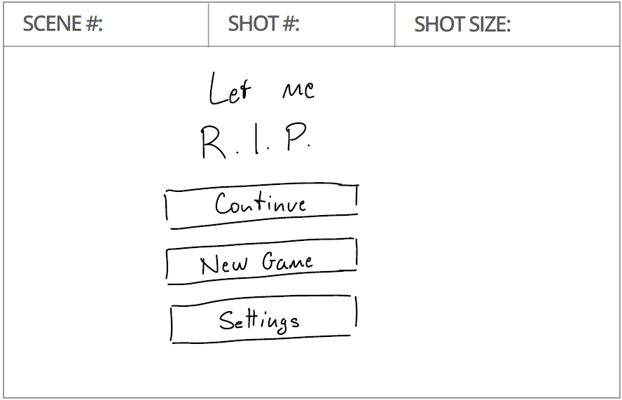

#### Character creation

This view allows the player to insert a nickname for his new character and to select its class.  
When focusing over a class its description will be displayed in the center of the screen and a sample corpse on the right.

Once the player has typed his name and selected the class can start playing by pressing the Create button.

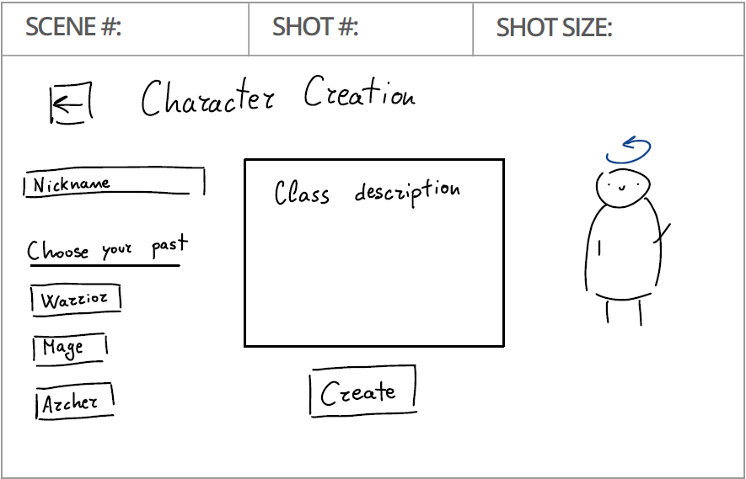

#### Combat layout

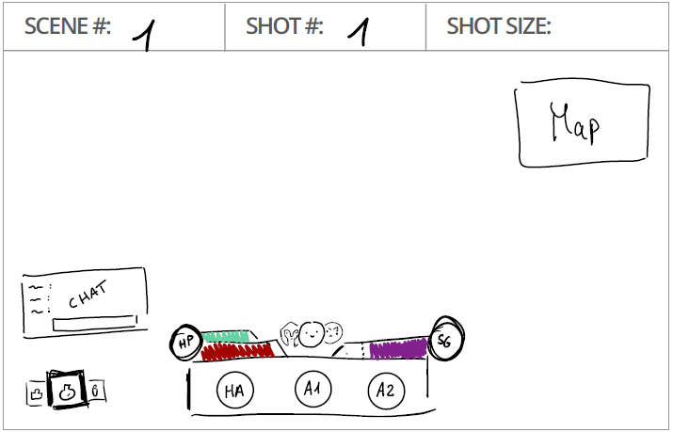

The above storyboard represents the UI seen while in combat.

In any other instance every piece of gui will hide except for the chat.

The red bar represents the HP pool of the body, depleting from right to left, the light green bar on top of it represents the HP pool of the spirit, depleting from right to left

The purple bar on the right represents the Spirit Gauge, depleting from left to right. A marker on the spirit gauge indicates the required SP to transform.  
When the SG indicator is reached a visual effect will be displayed to inform the player that he can now transform, as shown below:

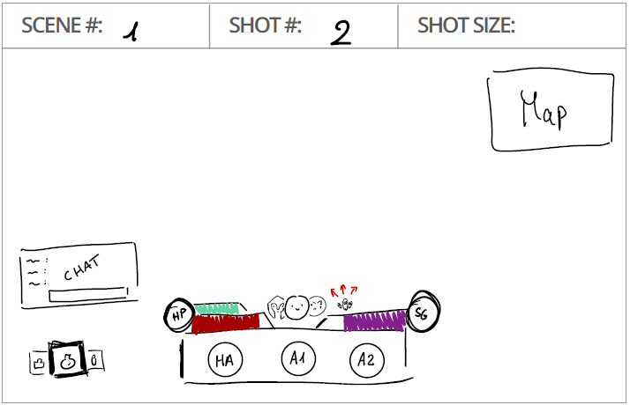

Between the bars are the faces of the body and its available transformation, the one in the front is the current form. When switching between forms, the faces will swap places as shown below:

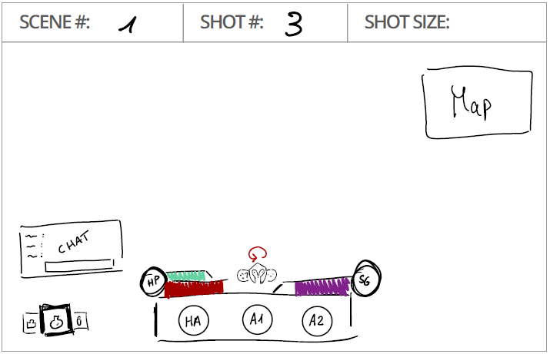

Below the health bars and the spirit gauge are the icons for the skills, when one of those is used the cooldown will be displayed, so that the player is aware when it will be ready again.  
The light attack and dash are not displayed due to their low cooldown, we expect from the players to go at feel, keeping some sort of “rhythm”, when those abilities are ready.

On the top right we have a mini map, which can be expanded as shown below.

Every square represents a room that might have in it an icon to represent a specific type of room.  
While the player moves between rooms, the one that he is in is kept on the center of the mini map, moving the rest to the sides, and possibly hiding part of it

When expanded it will occupy a significant part of the screen showing the whole map and, if the dungeon is big enough, he will be able to navigate through it.

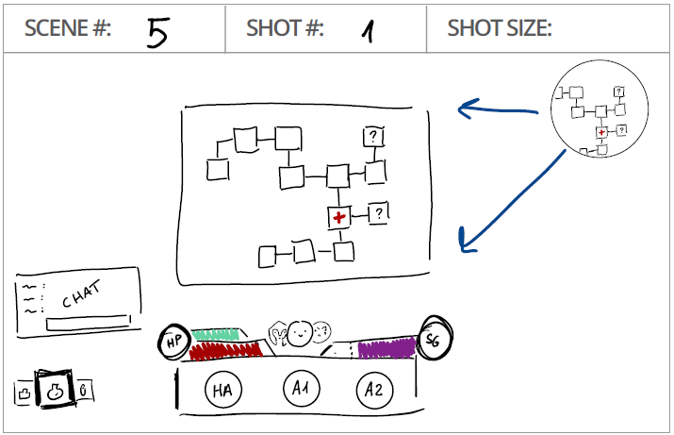

On the bottom left corner, we have the Elixir Wheel, displaying the selected elixir. The one on the center, on top of the others is the selected one. When used a cooldown timer on top if it will appear in the same way as the abilities.

When switching between selected elixir the wheel will rotate, placing a new elixir icon on top and shifting the others on the left or right as shown below:

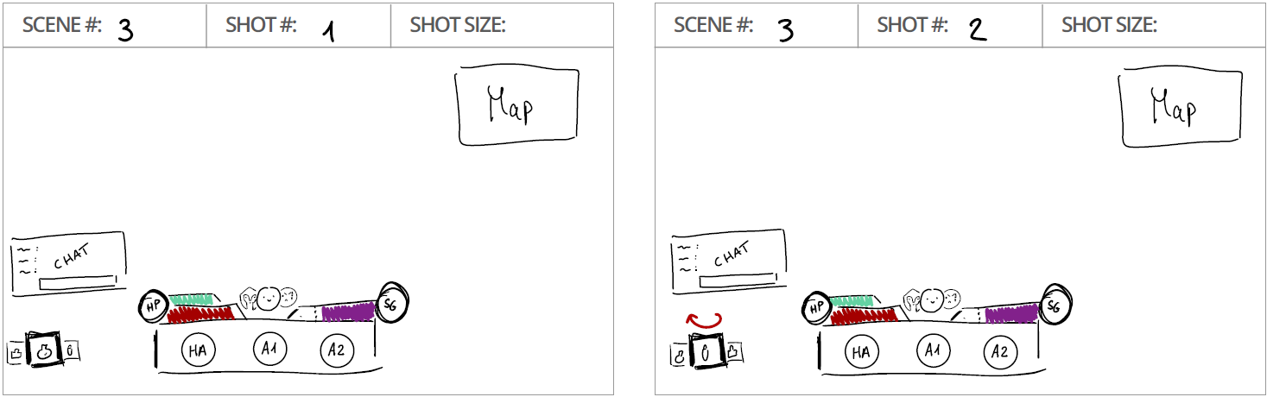

On top of the elixir wheel we have the chat, which we will keep with a transparent background and after 6 seconds of “silence”, meaning that no one writes for 6 seconds, the chat hides.

The bottom right corner is intentionally left free to let streamers to put their cam in that spot.

#### Dialogues

When the player interacts with NPCs or interactable props a dialogue UI will take the place of the combat UI, it will swap with a slide animation as shown below:

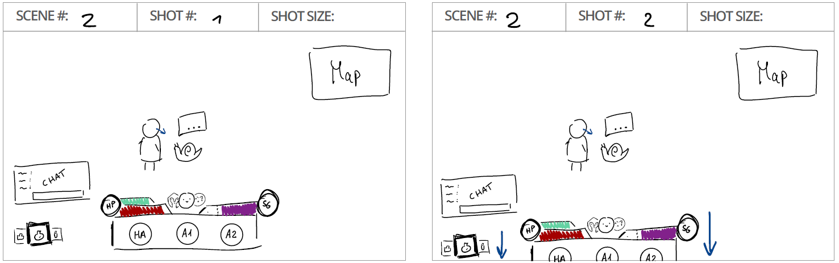

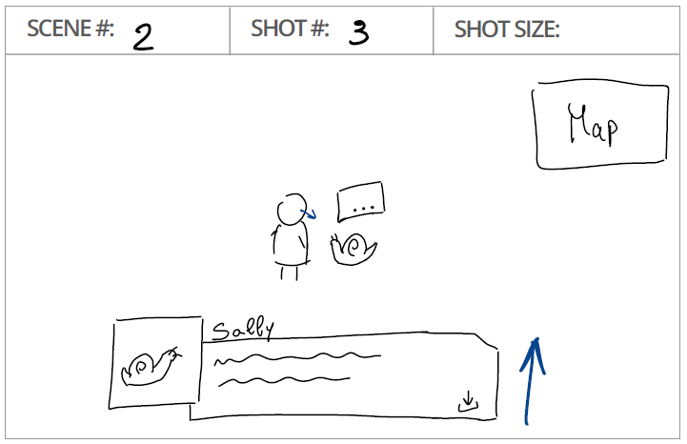

#### Looting

When the player finds an elixir while in a dungeon he will have to decide where to place it on the wheel and eventually discarding one, this selection has a panel that takes a significant part on the screen, and has in it the equipped elixir, the found elixir and a trash icon that is used to discard the found elixir.  
If the player hovers on an elixir a description panel will appear on the left with informations regarding the hovered elixir as shown below:

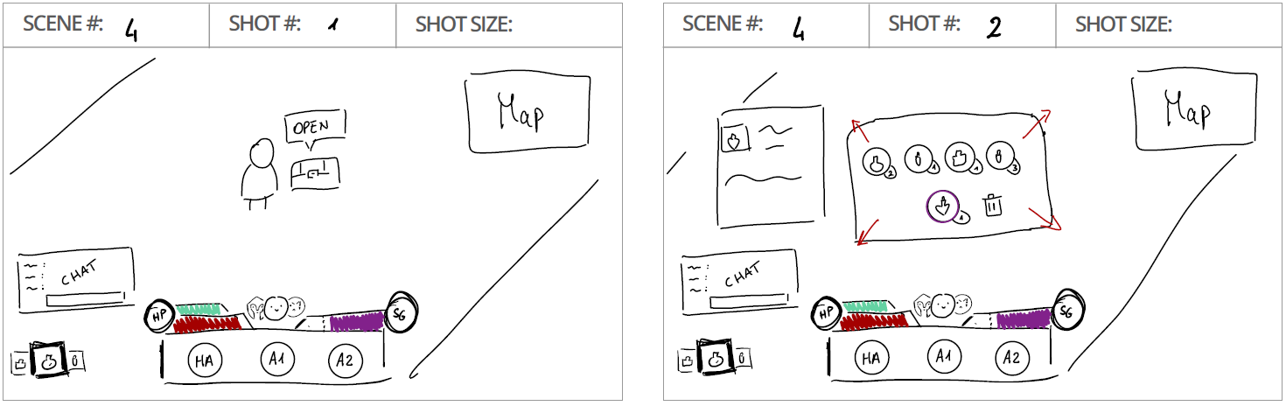

#### Shops

When shopping at the Smelly Corpse or Mercy the UI will be at full screen, covering everything below it.  
The following storyboard represents the Smelly Corpse and here we define a style for our next UI, having on the left a subdivision of items (corpses, elixirs and key items), on the top right our currencies, a list of items on the left and a description of the focused item on the right.  
In addition to this, we have a refresh timer on top, used only for the Smelly Corpse, it indicates the remaining time before the corpse list refreshes, this process can be sped up by spending AC.

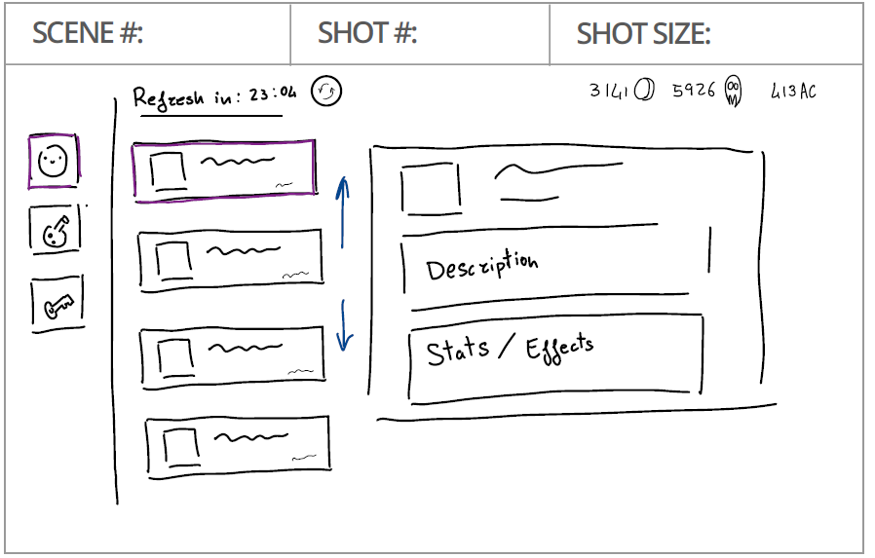

Starting from the above design we want to keep some consistency between the shops and the inventory.

#### Character information

In the following storyboard represents Milly’s shop and it maintains the above style, adding the body on the right. Later when we will need to display the body, we will always display it on the right.

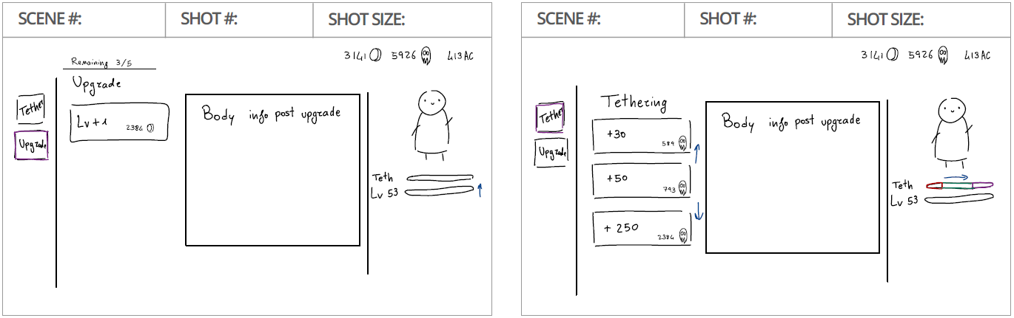

We divide the personal character space into 3 tabs: Character, Abilities and Inventory

In the character tab we see every statistic related to the spirit and the worn body, on the right we display the character and at his left we list vertically the icon of the worn body and the 4 slots of the elixir wheel.

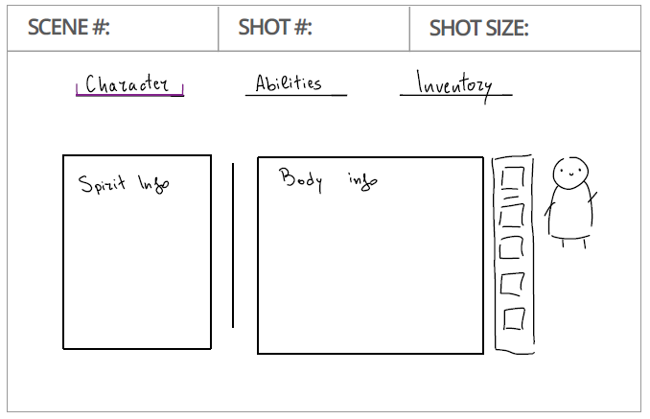

In the abilities tab the player can read the description of every ability with its scaling and the damage with the current stats.  
We also divide it in 3 sections on the left, one for each form (base form, transformation 1 and 2).

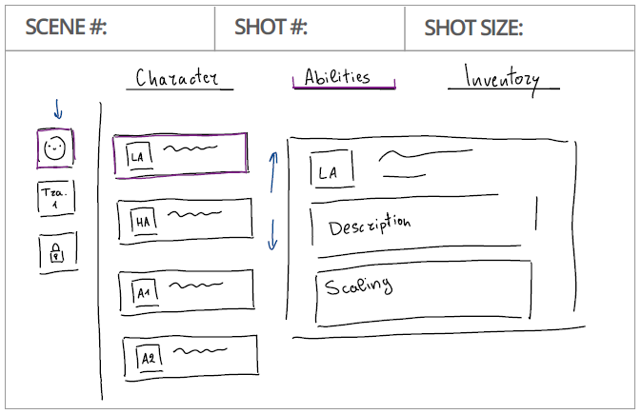

In the inventory tab we have every item that the player can collect and keep indefinitely, we apply the same division that we used in Schrodinger shop so that we have it as organized as we can.

On the right we display the player with the worn body and elixir slots as we did in the Character tab and the player can use it to change the equipped corpse or elixirs.

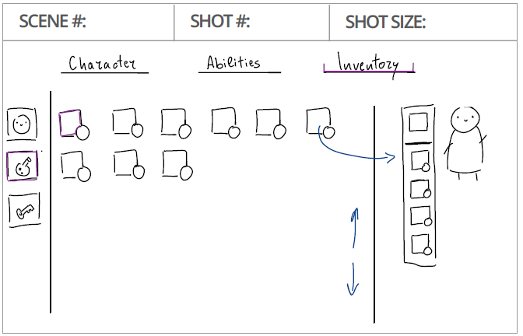

#### Friend Invite

In the following Storyboard is represented the UI that will allow the player to manage friends, he will be able to:

* Chat with friends
* Check his friend list
* Invite a Friend inside the party
* Search a player
* Check his recent encountered list of players
  + Add as a friend

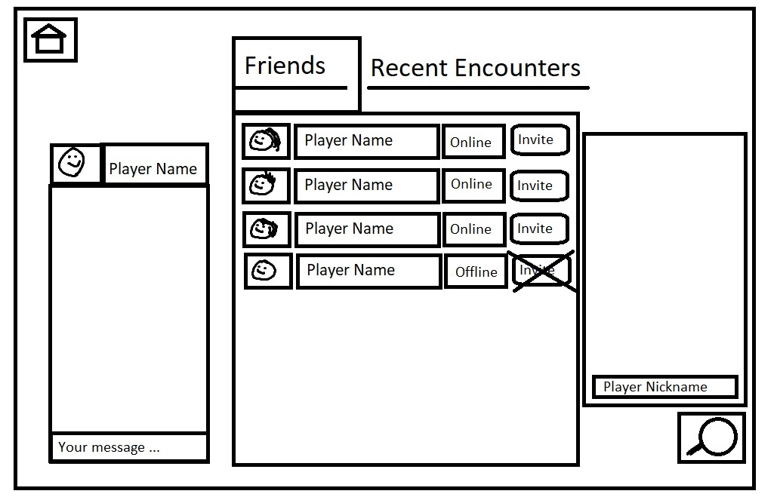

### Flowchart

#### Starting Menu

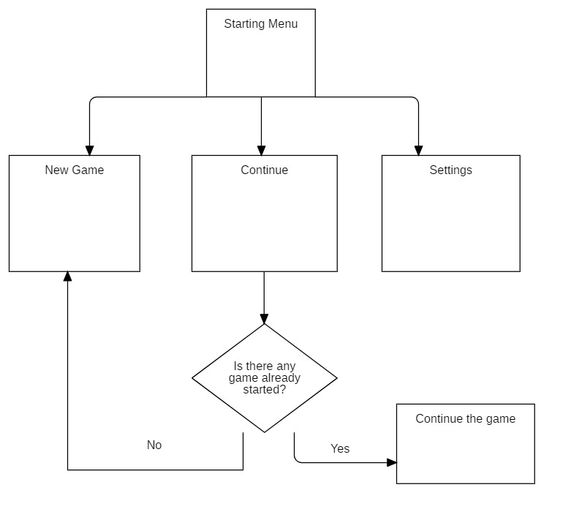

#### In Hub

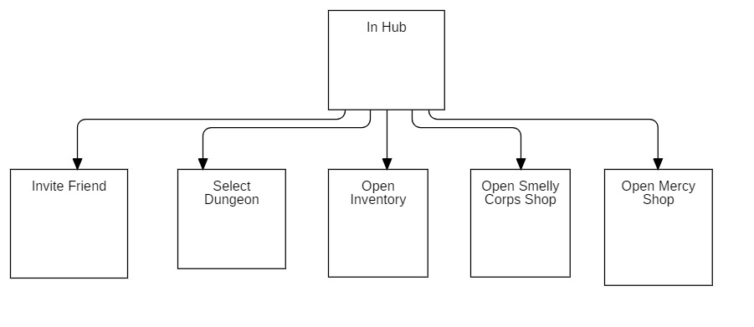

#### Smelly Corpse

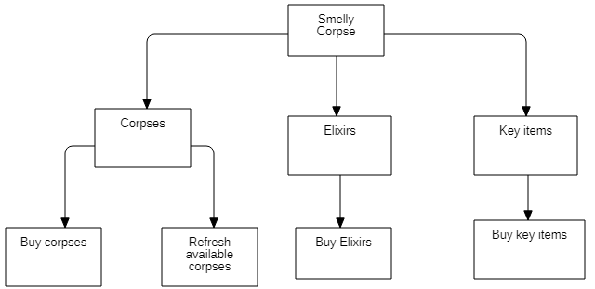

#### Milly the Tailor of Souls

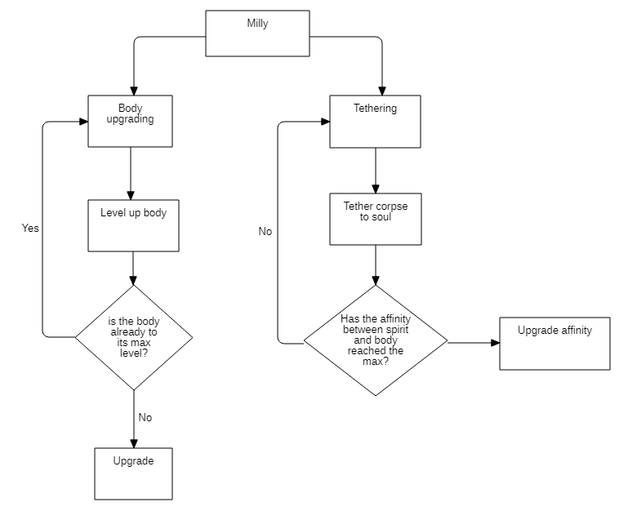

#### Character information

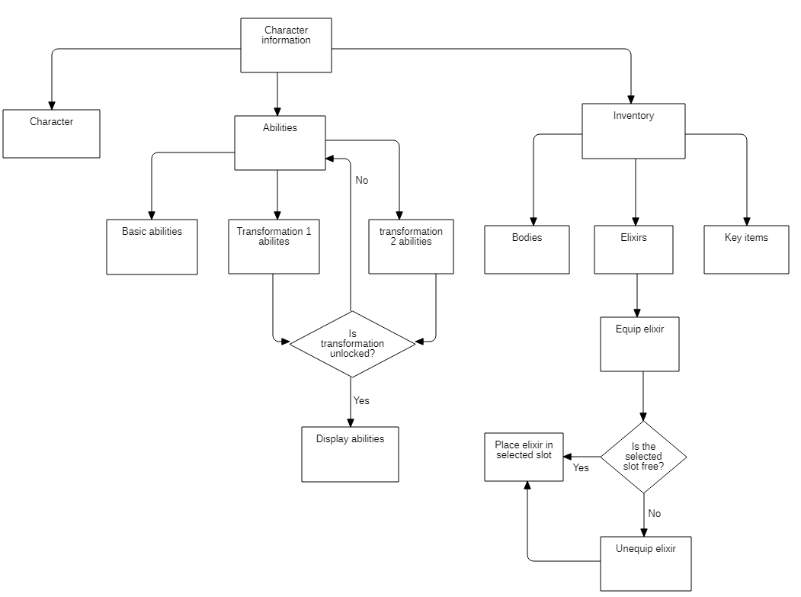

#### Friend Invite

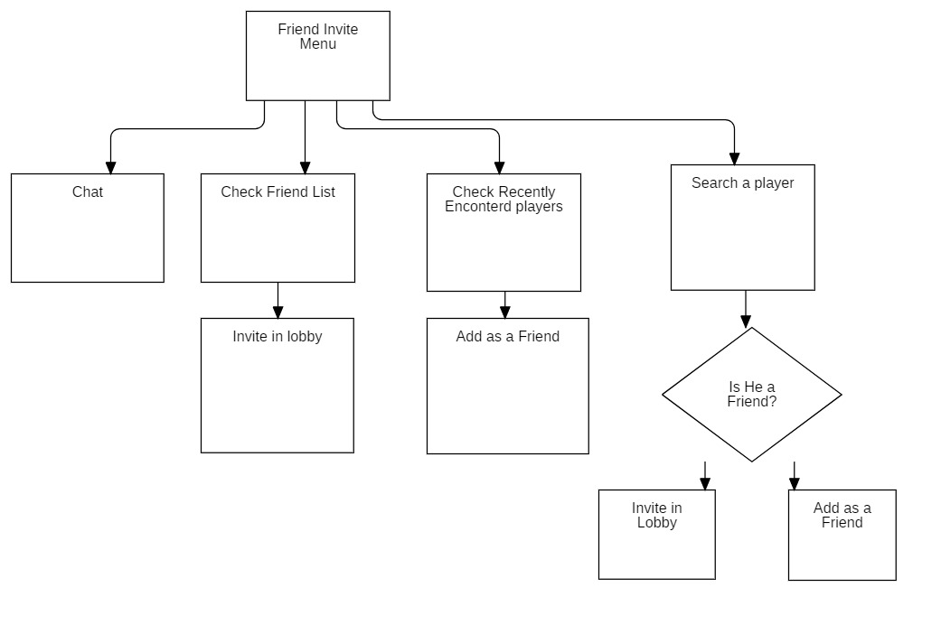

#### In Combat

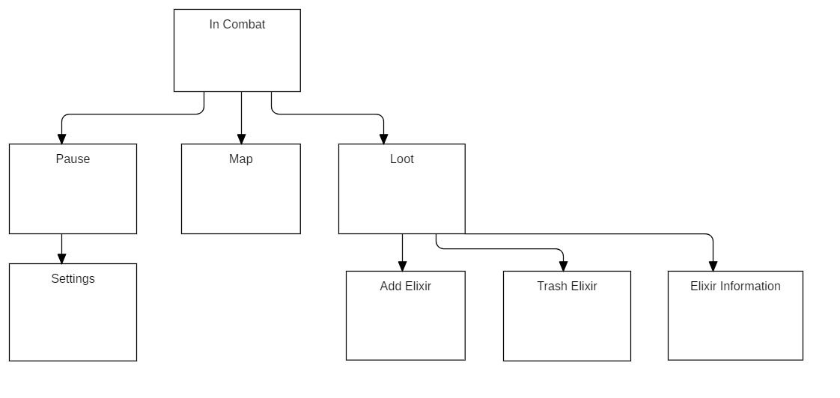

# GAME CHARACTERS

## MAIN CHARACTERS

### The Poor Soul

A simple soul died a few years before the story takes place. He lived the life of a soldier, where he fought to protect civilians, but never had the chance nor the need to go into a battle.

He died by old age, with no regrets, happy to end his journey on earth.

### Gorb

The son of a noble family, famous for their innate magic abilities but poor Gorb, does not seem as good as their parents expect him to be, even though he believes himself to be an incredible warlock.

This illusion is supported by his ego and several excuses when a spell turns out wrong, he may give the fault to bad ingredients, the weather, or the salty soup he ate the night before.

The two things that he cares about in life are his ego and his dog Chili, who unfortunately passed away.  
Driven by sadness, Gorb decided to steal one of the ancient tomes in the private library of his parents and cast a spell that was supposed to bring back Chili to life, and it did but, at his unbeknownst, he also brought back to life thousands of souls from the Carian catacombs.

### Sally

An old necromancer that lived a few centuries ago, who got stuck into the body of a giant slug trying to reincarnate into a younger body.

Sally, being a necromancer, has extensive knowledge of magic and its history.

## ENEMIES

### Calsifer

An old general of the army of the undead who fought the Mòn family centuries ago, although he lost his battles and eventually the war, he was able to deplete Mòn’s resources enough to make them retreat from their governing position.

## SIDE CHARACTERS

### Schrodinger

A mysterious talking mole with even more mysterious capabilities.  
He can reach any place unnoticed, scavenge whatever he finds, and goes back to his shop.

Nobody knows how he can carry so many corpses with such speed and ease.

### Milly

A young tailor proficient in necromancy. She once worked for a necromancer who decided to make her his right hand due to her weird addiction to skin and incredible resistance to gore, but this poor necromancer is now dead, probably.

### Tain

(Crestfallen)

A Crestfallen spirit awoken long before us. He traversed the outside world and the catacombs multiple times.

He is a strong melee fighter that we encounter right before the entrance of the boss arena (of the prototyped level), sitting on a rock, wearing brown armor with no helmet. From a distance it looks like he is resting or sleeping but by looking closer you notice his wide-open eyes even though he is just not moving or responding.

If the player interacts with him, Tain will reply with:

“I’ve being struggling for so long and yet I could not accomplish anything. Why bother then, I could have just been standing still for all this time and I would have accomplished the same results: nothing. I tried so many times that I stopped counting long ago and yet this mountain seems too big to climb.

I still have all eternity, but why should someone keep trying harder and harder when you could just standstill.

Death, the end of all things, the event that I was most scared of, but now... it’s what I most desire. When there is no end, everything is your prison, your hell.

The sooner you accept it the faster you will learn to rest with your eyes open”

### Mercy

A mysterious old man, who seems to have in his possession several interesting artifacts, but he rarely accepts gold for his services, mostly Awesome Coins (AC), obtained only by showing the uttermost devotion to the catacombs (paying real money).

# GAME WORLD

## HUB

Also known as the Carian catacombs, built to bury thousands of fallen soldiers from the Red War.

It hosts different dungeons entrances and three shops: Milly the Tailor of Souls, The Smelly Corpse, and Unknown.

Multiple souls might visit the hub at the same time, enabling players to stay together in the same hub and depart together to explore dungeons.

## DUNGEONS

A dungeon is a linked set of rooms. Such a set always must include a starting room and an exit room.  
Every dungeon will narrate a slice of the world’s history.

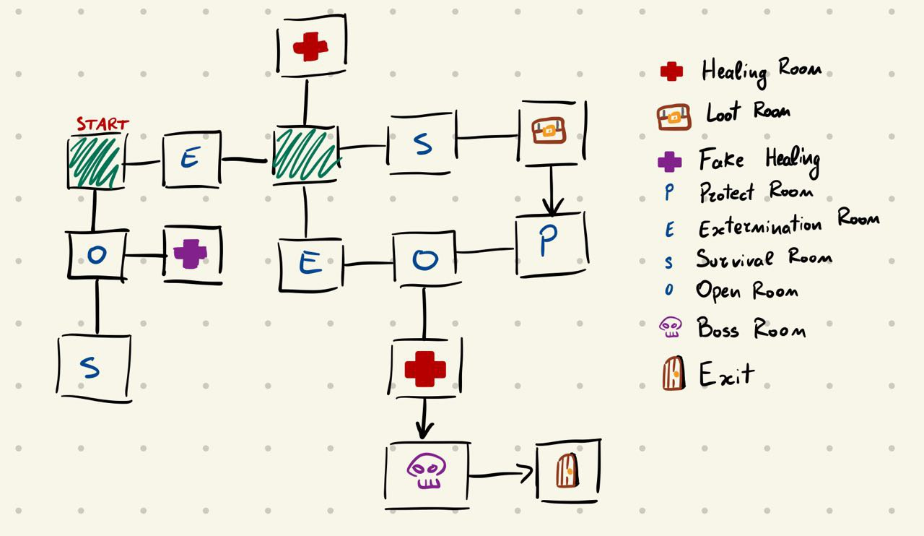

## ROOMS

Several types of rooms can be found in dungeons, some may require a different approach to complete and others do not necessarily need to be completed to proceed.

**Healing room:**  
A healing spot at the center of the room stands, healing the player if a fee in gold or spirit gauge is paid. Next to the healing spot, there might also be Schrodinger, which will return your body if you happen to lose it in the dungeon.

**Boss room:**  
A strong enemy is waiting to be defeated. A boss may differ from one another. After defeating a boss, a reward is assigned to the player(s).

**Open room:**  
Different enemies are placed around the room. All the gates are open, this room is optional. If cleared the player is rewarded with the enemies’ loot. It might be useful to restore the spirit gauge and collect more gold and experience.

**Survival room:**  
As soon as the player enters the gates of the room lock, nothing can exit but other players can still enter (in the next 10 seconds if we want to also lock the entrances). For the next 40 seconds, enemies will keep on spawning. The number of enemies might be overwhelming for the player, but it does not have to be able to kill all of them, the main objective is surviving.  
If the player(s) succeed, they are awarded a small healing spot.

**Extermination room:**  
As soon the player enters the gates lock, nothing can exit but other players can enter at any time.  
The room is filled with enemies, and the only way out is to kill every single one of them. If the player manages to clear the room in under 20 seconds, extra loot will be awarded.

**Protect room:**  
The gates of the room are open at any time.  
A hopeless soul stands at the center of the room getting attacked by surrounding enemies.  
The main objective is to defend the hopeless soul. If the player protects it for 30/40 seconds extra loot will be awarded.

**Loot Room:**  
A chest stands at the center of the room, if the player interacts with it, loot will be awarded.  
The player can also interact with other props in the room, getting insights into the story.

**Fake healing room:**  
It looks like a Healing room, but as soon as the player interacts with the healing spot, the gates will lock and several enemies will spawn, the player will have to kill them to open the gates and use the healing spot (at no cost?).  
The only aspect that gives out that this is not a usual Healing room is that Schrodinger will not appear right away if you enter the room without a body but only after clearing the enemies.

**Empty room:**

No enemy or loot awaits the player in this room, but just gates to other rooms.

**Exit room:**  
No enemy awaits the player, but an exit and sometimes also loot or props that give insights into the story.

**Reference with Unity unit of measurement.**

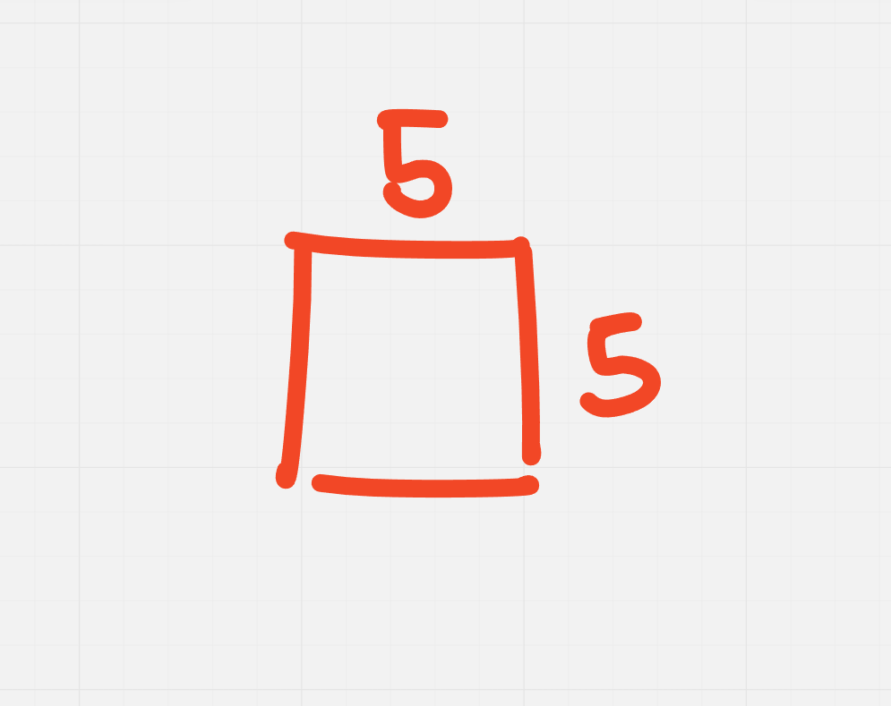

**Room disposition inside the dungeon.**

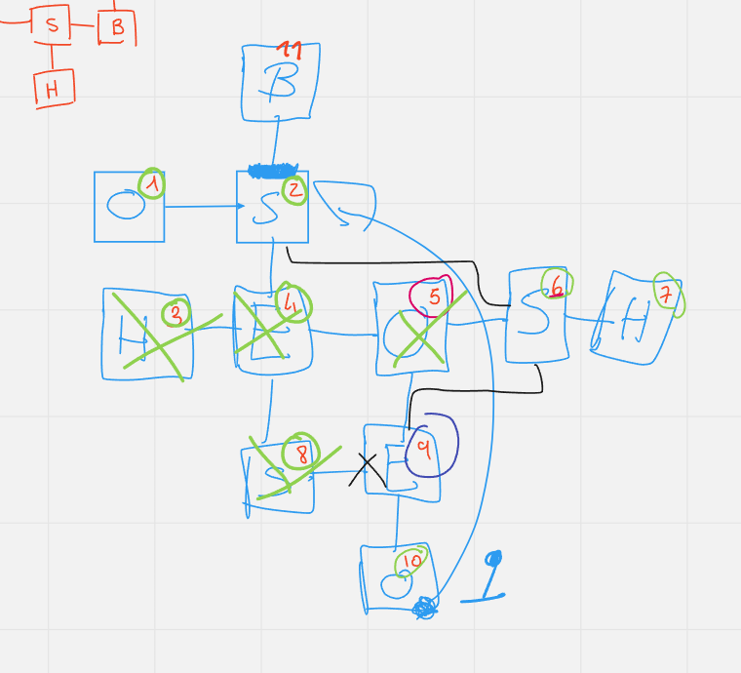

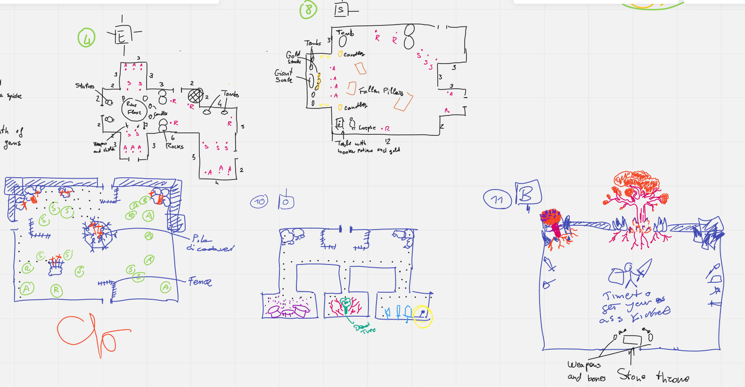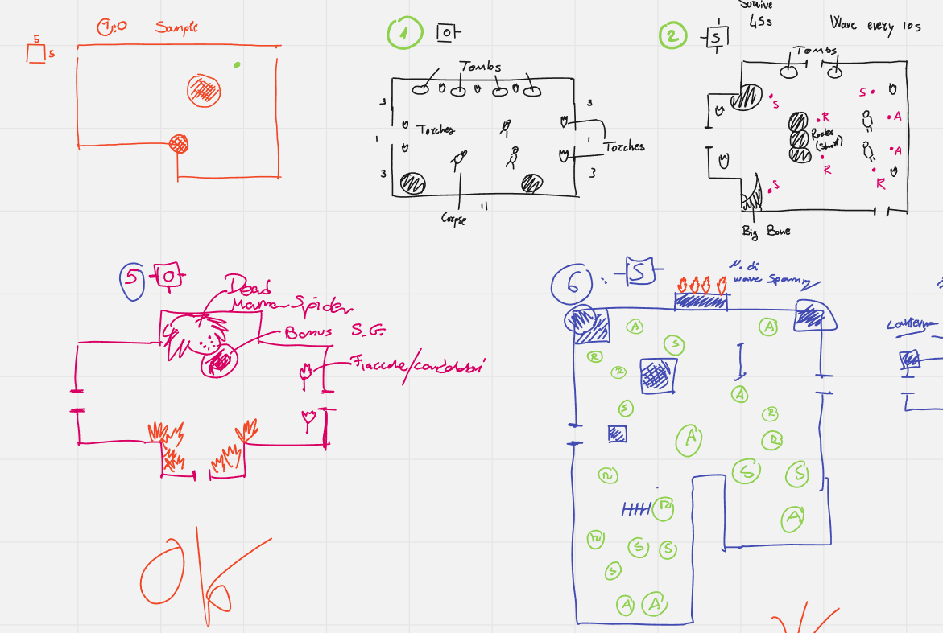

## CARIAN DEPTHS

A mysterious cave that the legends say led to the entrance of the afterlife’s reign.  
It is a single-player or multiplayer challenge structured in a sequence of procedurally generated dungeons.  
The entrance of the Carian’s Depths is unlocked once the player meets Tain right before the entrance to Carian’s boss fight

Carian’s Depths are divided into 20 depths levels, and every level of depth is represented by a dungeon, and completing one allows the player to descend further.

Every dungeon is made of rooms, the number of rooms is always around 10, 3 of which must be the start room (or entrance), a boss room, and an exit room. The only dungeon that does not completely follow this constraint is the last one, which does not have an exit room.

The exit room contains a door to descend to the next depth level, a healing spot, and two loot chests.

Differently from the campaign dungeons, the non-boss rooms are procedurally generated, while the boss ones are still manually made.

The available rewards are elixirs and souls and will be obtained as usual through enemies and loot chests, **gold and experience cannot be obtained**.

The difficulty of the dungeons will be tuned to allow the player to get through 3-5 levels when discovered, and swiftly increase the difficulty until reaching end-game difficulty around depth 16.

The encountered bosses are the ones that the player can encounter in campaign dungeons, eventually with higher stats to meet the desired difficulty.

The last boss will be Carontee, the guardian of the gates of the afterlife, which is also the last boss of the campaign.  
If the player is able to reach Carontee before meeting him in the campaign, Carontee will give the following dialogue:

“*Oh, grieved soul*, *thy sin won’t be forgiven, for him who spared thou soul are a rotten fruit fallen by the tree of life. As such, you are banned from the ever-resting reign, and no other action will be taken.*”  
Ending the challenge teleporting the player to entrance of the Carian’s Caves.

If the player reaches depth 20 after meeting Carontee in the campaign, the actual boss fight will begin, with an extra phase in it. If he is defeated the Carian’s Caves challenge will end.

When the player dies or reaches the end of the caves, the challenge ends, a set of statistics will be displayed, with them: the reached depth and the time taken to reach it.

The entrance is free.

**Leaderboards**

A leaderboard with the best times to reach depth 20 will be right outside the cave.

There will be three leaderboards, one with the personal bests, one displaying the best within your friends and a global one.

## ALLIED CREATURES

|  |  |
| --- | --- |
| Statistics |  |
| HP | 1.5*Player HP |
| STR | 2* Player STR |
| DEX | 0.5 * Player DEX |
| INT | 0.2* Player INT |
| Defense | 1.2* Player Defense |
| Swiftness | 35 |

Behaviour:

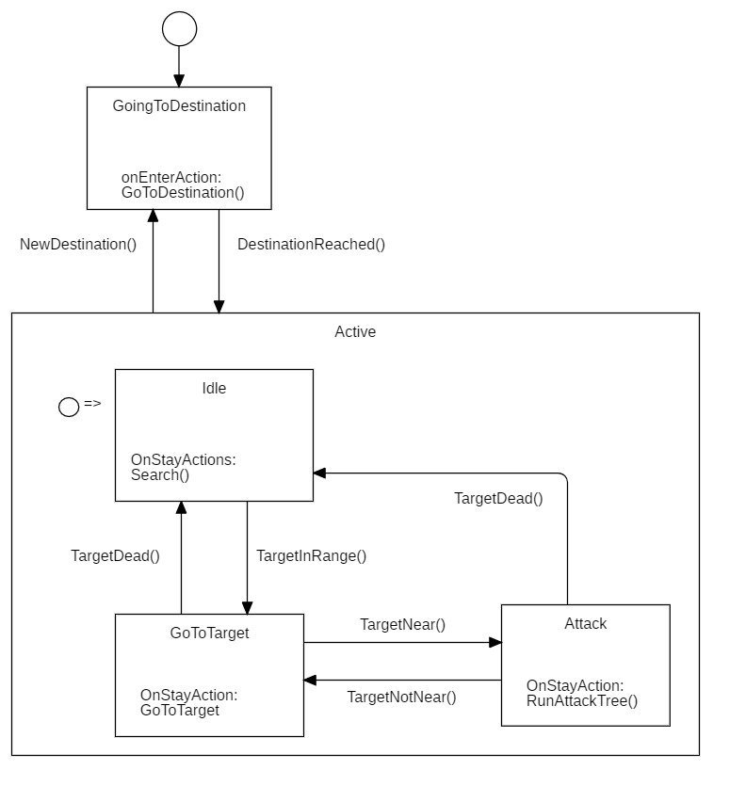

## ENEMIES

Various enemies dwell in the rooms of the catacombs. A different approach is required from the player to defeat each enemy.

* **Simple:** a melee insane soul approaches the player when in line of sight and within range. If it loses sight, it will move to the last place where it has seen the player. Its attack is slow with low damage.
  + **Behavior:**

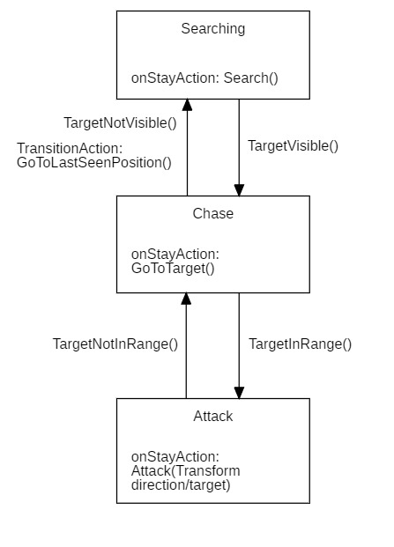

**[Simple’s AI4Videogames F.S.M.]**

* **Defensive:** with a big shield in hand, this slow-paced enemy can be defeated only if hit on the back. It deals a very low amount of damage, but its key role is being an obstacle between the player and other enemies with its medium-large pool of life.
  + **Behavior:**

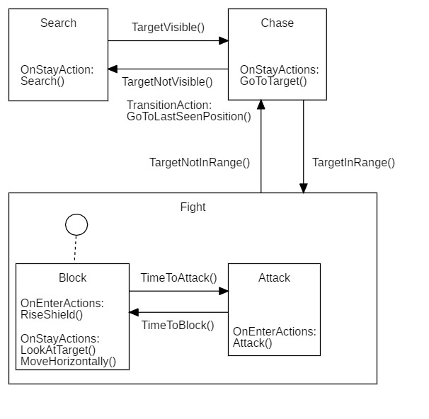

**[Defensive’s AI4Videogames F.S.M.]**

* **Archer:** it wields a longbow, dealing damage from long distances.
  + **Behavior:**

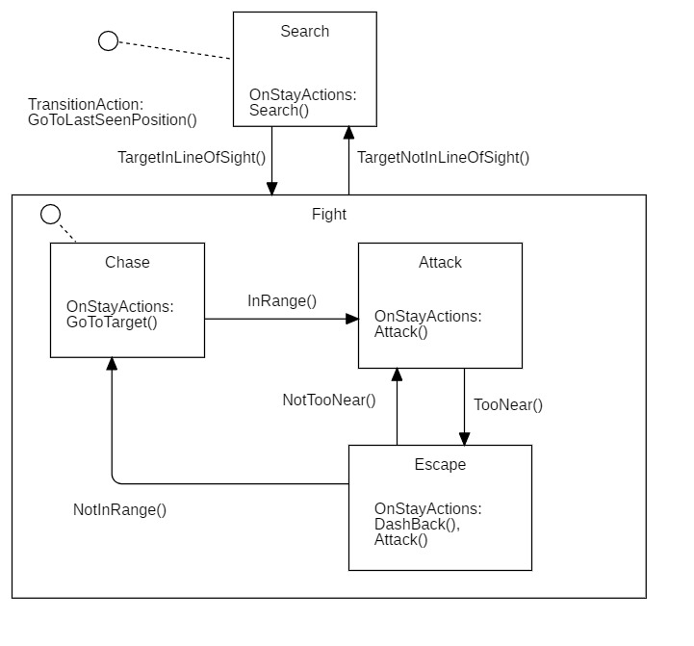

**[Archer’s AI4Videogames F.S.M.]**

* **Suicide:** the most insane state that a soul can reach. It quickly runs up to the player letting himself blow up dealing a large amount of damage in a small area.
  + **Behavior**



**[Suicide's AI4Videogames F.S.M.]**

* **Summoner:** a warlock that can deal both deal damage from medium-long distances and summon multiple minions.
  + **Behavior:**

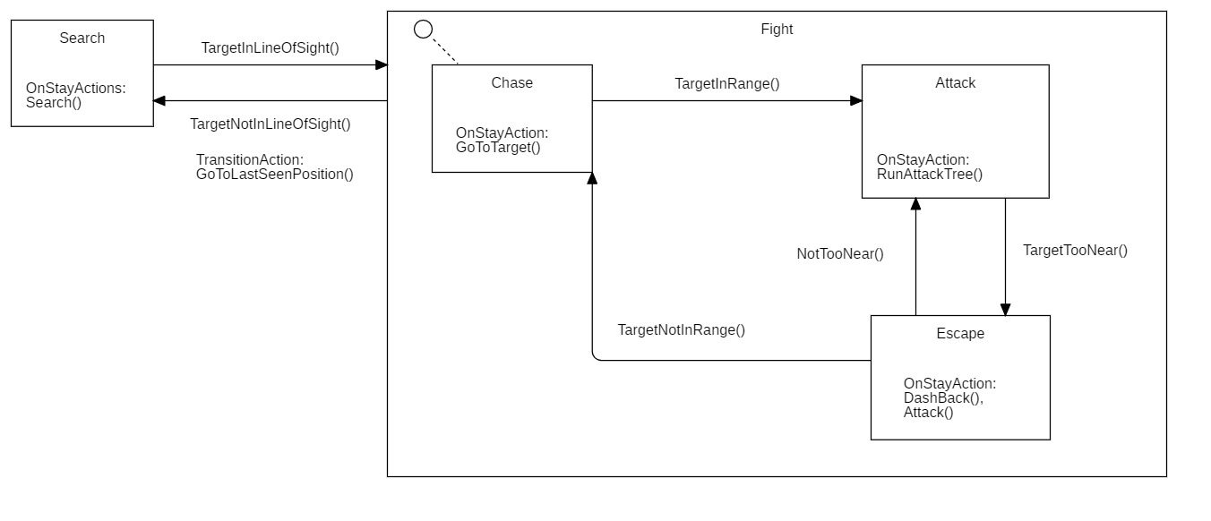

**[Summoner’s AI4Videogames F.S.M.]**

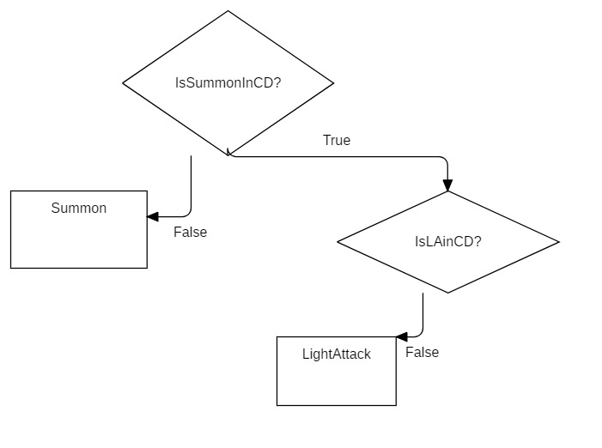

**[Summoner’s Decision Tree: Attack Tree]**

* **Summoner’s minions:** small melee enemy, it deals extremely low damage but is extremely fast.
  + **Behavior:**



**[Summoner’s minion Finite State Machine]**

**Crimson Tentacles:** A long unmovable tentacle, which strikes everything in his range

**Swarm of Bats:** Neutral beast that attacks melee a random creature

|  |  |  |  |  |  |
| --- | --- | --- | --- | --- | --- |
|  | HP | Attack | Defense | Swiftness | Ranged |
| Simple | 5o | 10 | 10 | 20 | No |
| Defensive | 100 | 6 | 20 | 13 | No |
| Archer | 50 | 18 | 8 | 25 | Yes |
| Suicide | 30 | 55 | 5 | 40 | No |
| Summoner | 100 | 15 | 8 | 10 | Yes |
| Minion | 35 | 8 | 5 | 30 | No |
| Mother spider | 140 | 13 | 15 | 20 | No |
| Spiderling | 35 | 5 | 8 | 25 | Yes? |
| Swarm of Bats | 40 | 7 | 10 | 25 | No |
| Crimson Tentacles | 150 | 20 | 10 | 0 | No |
| Calsifer P1 | 1000 | 45 | 25 | 18 | No |
| Calsifer P3 | 1000 | 45 | 15 | 23 | No |

### Calsifer

Calsifer wears chain armor and wields a one-handed sword, it is presented as twice as big as the player.  
This boss fight is divided into 3 main phases.

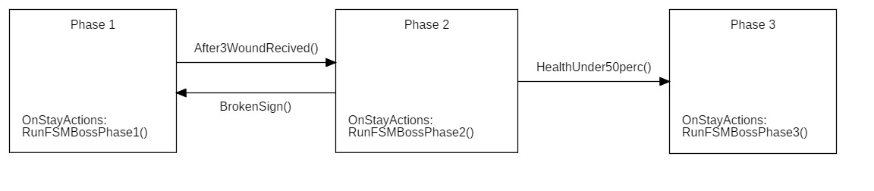

**[Calsifer’s Phase AI4Videogame FSM]**

**Phase 1**

He first chooses a first random target and chases it. When he reaches melee range, he proceeds by attacking such an enemy. After a set amount of time, he jumps back, changes target and dashes towards it and attacks it right away. Every enemy encountered while dashing is pushed away and receives damage.  
When a player walks out the melee range, the boss might dash or walk towards the player.

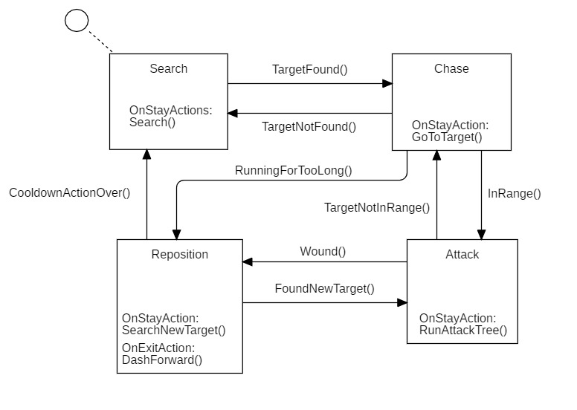

**[Calsifer’s Phase 1 - AI4Videogame FSM]**

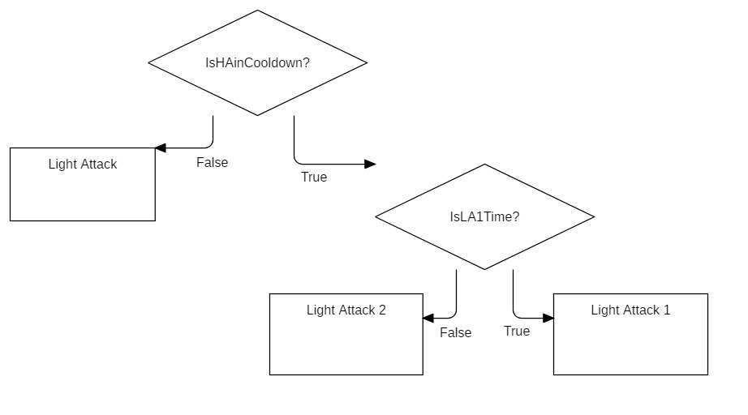

**[Calsifer’s Decision Tree]**

**Phase 2**

The boss is hurt and tired, it will find protection under a magic shield for the entirety of the phase.  
Numerous enemies will spawn to cover Calsifer. Within the army, 4 Crimson Tentacles will always spawn nearby Calsifer.  
To win this phase, the player must defeat every enemy on the field, except the boss.

Also, during this phase, a red circle will appear below Calsifer with an arrow pointing to a random direction. If the player is able to hit Calsifer in such direction, then it will deal 250 damage to the boss and it will regain Spirit Gauge.  
This interaction can only be made within 15/20 seconds from the start of this phase.

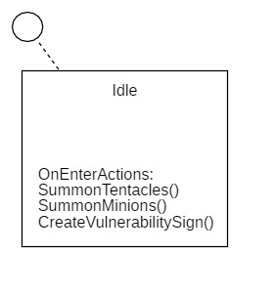

**[Calsifer’s Phase 2 - AI4Videogame FSM]**

**Phase 3**

Calsifer comes back up, vulnerable again, it will behave in the same way as Phase 1 but il will dash back more frequently, also whenever he dashes back a few enemies will spawn to aid him in this fight.

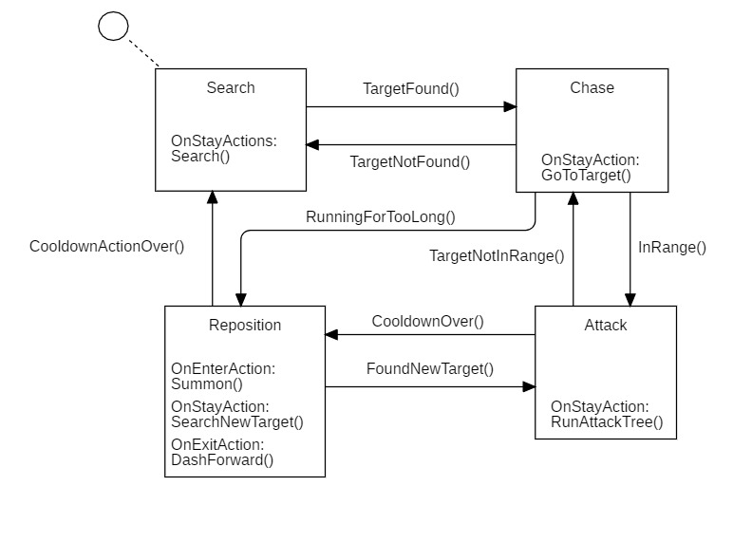

**[Calsifer’s Phase 3 - AI4Videogame FSM]**

**Multiplayer Adaptations**

If Calsifer is fought by multiple players his life will be multiplied for the number of players, in addition to this, during phase 3 more enemies will spawn at every dash back.

# STORY

## SYNOPSIS

After an unexpected resurrection, our player meets a giant talking slug named Sally, which explains that someone or something resurrected an enormous number of souls and many of them are in an insane state causing nothing else but chaos. The player and Sally agree to investigate together on this case.

The player will get to know Sally better and discover that she is a necromancer stuck into the body of a giant slug and due to its limitations, she needs someone else’s help to solve this problem. Sally explains that this exact event happened already many centuries ago and it was for war reasons, and she is worried that the story will repeat itself again.

After several investigations they get to know that Calsifer, an old friend of the necromancer that resurrected many undead centuries ago is buried in this exact catacomb.  
The player will meet Calsifer, who is also in an insane state, believing that he is still alive and leading an army of the undead. The player will eventually defeat Calsifer and he will reveal that the resurrection has taken place in Milla, the capital of the reign.

With this information in their hands Sally and the player will exit the catacombs and head off to Milla where, after a few days they will find the house of the suspected necromancer but at their disbelief, he is just a normal person living his life with his beloved dog.

## COMPLETE STORY

Our player begins his journey being revived in the material world as a spirit for unknown reasons.  
The room is almost completely dark, dimly lit by a few torches fixed at a distant wall, behind him a spoiled tomb with his name on it and a couple of dried flowers, it looks like he was revived where he got buried, in the Carian catacombs, the largest catacomb in Milla, built to contain the dead bodies of the Red War.  
After a bit of wandering in the passages of the catacombs, he starts noticing that there is not a single unbroken tomb.

From a distant hall he starts hearing something, someone nervous.

“Heck, heck, heck...”

At the end of the hallway a bright hall with mossy walls and an enormous slug, nervously sliding back and forth, “stands” in the middle.

“Heck, heck, heck...”

The player approaches the big talking slug, amazed by this bizarre creature.  
He meets Sally the Slug who, very worried, starts asking numerous questions to the player, trying to understand if he is mentally numbed from his revival.  
She later explains that many souls have been brought back to life and many are in an insane state of mind, bringing nothing but chaos and destruction, and that is why she is looking for someone to help her investigate what caused this mass resurrection and what are the reasons behind it.  
The player will willingly propose to help her, stating that his only interest is to go back to rest.

[investigations that we still not have decided upon]

During the investigations the player gets to know Sally better, she discovers that she is an old necromancer that got stuck in the body of a giant slug while trying to reincarnate in a younger body (she was definitely doing meth) and that she lived the era of the Lymph, a now a banned resource that had hallucinatory effects if mixed with magic. She has extensive knowledge about the history of our world and that her preoccupations are linked to an old war, happened centuries ago, called the Red War, who has seen the Mòn’s army, the governing family at the time, versus civilian militias trying to overrule the Mòn’s iron fist over the continent. Those battles tinted the land with the blood of the fallen soldiers due to the power of a ciphered tome, an ancient relic of a renown monarch versed in necromancy.   
One of the Mòn’s necromancers managed to decipher a spell that could drain the blood out of soldiers, this knowledge led them to victory, stating again their power over the continent.

Years went by and a small number of survivors from the Ghèram family, allied with the civilian militias, managed to steal the tome and to quickly decipher a second spell, resurrection.  
Not a long time after, they resurrected all the soldiers that battled the Red War and set off a second war which will unexpectedly see the Mòn family victorious again, but at a great cost, their armies and resources were extremely depleted, and it led to the decision to retreat from their governing position to a safer, smaller, and more manageable reign with the objective of protecting their remaining relics from being stolen.

This is what Sally is worried about: a second mass resurrection from one of the two factions that will escalate to a third war.

[more investigations]

The player and Sally discover that in these catacombs is buried Calsifer, an old Ghèram’s general who was close to the necromancer who resurrected their army; with this knowledge, Sally sends the player to this location and after defeating several insane spirits on his way, the player meets him.  
Still driven by madness, Calsifer thinks to be alive and that he is still leading his army of the undead, the player will eventually fight and defeat Calsifer, revealing a hidden exit that leads to a long underground passage.  
After a long way in, the player and Sally find themselves under a wooden floor and, with a few well aimed blows, the player smashes it making his way in.  
He finds a desk at his side, bookshelves everywhere, and an open door, with a light coming from another room.  
The player and Sally slowly make their way to the corridor, following the light source nervously sweating, ready to fight whatever brought all of this damnation.  
At the end of the corridor, another room with the door open and a crackling fireplace is visible from their view.   
Ready more than ever they burst in but, little did they know, a scared man with a dog in his lap is trying to hide next to a brazier.

## BACKSTORY

In this world magic and afterlife are canon.

Magic is something that is not accessible to everyone, but it is instead limited to a selected number of people, usually nobles.

We divide the history of our world into 6 different ages.

The first era, known as “The Shatter” has seen the fall of the most skilled necromancer that ever lived from the charge of monarch. With his fall, all his relics were stolen from bandits of the time.

The biggest families of bandits ended up splitting the relics and cause the shatter of the magic shield that was imprisoning and protecting the kingdom.

The second era has seen the different families, thanks to the new powers achieved by the relics, explore what were before known as the forbidden lands, during this exploration the family of the Ghèram found a mysterious portal to the word of the dead, where the godfather of the family, Sambaleth, met Carontee the guardian of the gate between the 2 words.

The third era was ruled by the Mòn family after winning the Crimson Battle against the alliance of the other families. So many soldiers died in this battle that the ground itself become red as blood. What came next was a period dominated with the force by Mòns.

Not all hopes where lost, Ghèram’s family was able to cast a mass resurrection enchantment, thanks to the relic and the new knowledge passed by Carontee, on the field of the battle. So many men came back from the word of the dead that they were able to build a new city of the undead.

Once the undead become strong enough to create and army, a new epic battle took place in the same red fields, where now the Mòn had to face a new and unknown army and their general Calsifer. It’s in this period that our dungeon refers to, thank to the soul of Calsifer that after losing in battle kept redreaming the same fight.

The 2 army were so well matched that at the end both lost so many men causing the family of the Mòn to call a retreat and run back to their castle to protect their relics.

While this was happening the other families, free from the dominance of the Mòns were able to gain the power of the kingdom and start a new peaceful period.

The era that came next is the one with less battles and events, it is called the lymph era. The event that named this era is the one where some unknown mage while experimenting with the lymh of the crimson tree, the trees that grew on the field of the battle, discovered a powerful drugs by enchanting this lymph.

This long and happy era ended with the rise of an Oligarchy where only mages and necromancers were considered strong and intelligent enough to represent the political power of the kingdom.

The last era has seen a violent insurrection of the mass of non-magical people that with only the force of their hands were able to swipe the mages and necromancer. The hate against magic was so intense that they fought to destroy the portal to the word of the dead and finally restore the non-magic power on the kingdom.

## NARRATIVE DEVICES

**NPCs**

The story will be narrated through various dialogues with NPCs, some of them even bosses.

**Environment**  
The environment will also give visual hints and insights about a specific topic, for example in Calsifer boss fight the red floor gives hints about the red war and his ability to summon minions that follow his order gives hints about his role in such war.

**Interactable props**  
Several props can be found around rooms and the hub that the player can interact with. A dialogue will appear describing to the player what the prop depicts and possible links with other topics. E.g.: a painting depicting a person wearing a crown and surrounded of people with

## SUBPLOTS

### Crestfallen Souls

The Crestfallen souls, dwell in our world, locked out of the afterlife centuries ago due to necromancers’ experiments.  
After years and years on wandering within the lands, many of them lost hope, slowly losing their mind. Some were driven by madness, some got emptied of any emotion and others still wander with a loose sense of hope.

A small number also dwells in the Carian’s Catacombs, where the legends say to be an entrance to the afterlife, deep down a cave, known as The Carian’s Depths.  
For many this is just a children tale but for Tain, a Crestfallen soul, it’s the closest thing to salvation.  
He tried an innumerable number of times but never reached the bottom. With time this cave became the closest thing to Hell for him and for the several souls that tried but failed.  
No one has ever seen or reached the end of those caves, letting this cave be a mystery and the entrances to the reign of the afterlife just a legend.

# MEDIA

The following list describes the assets needed.

## CHARACTERS

### Spirit

* 3D model
* Animations
* SFX for skills, movement, and dialogue interactions
* VFX for skills and movement



The color of the spirit of the host of the lobby will be blue:



The color of the spirit of the second player in the lobby will be green:



The color of the spirit of the third player in the lobby will be violet:



### Bodies

As bodies are intended every character aside from the spirit that will be controlled by the player such as the basic classes and transformations.

* 3D model
* Animations
* SFX for skills, movement, and dialogue interactions
* VFX for skills and movement

Also, for every skill that requires it are also needed 3D models (e.g.: cross model for Beacon of Hope).

**Archer**

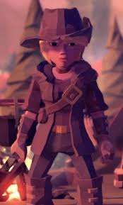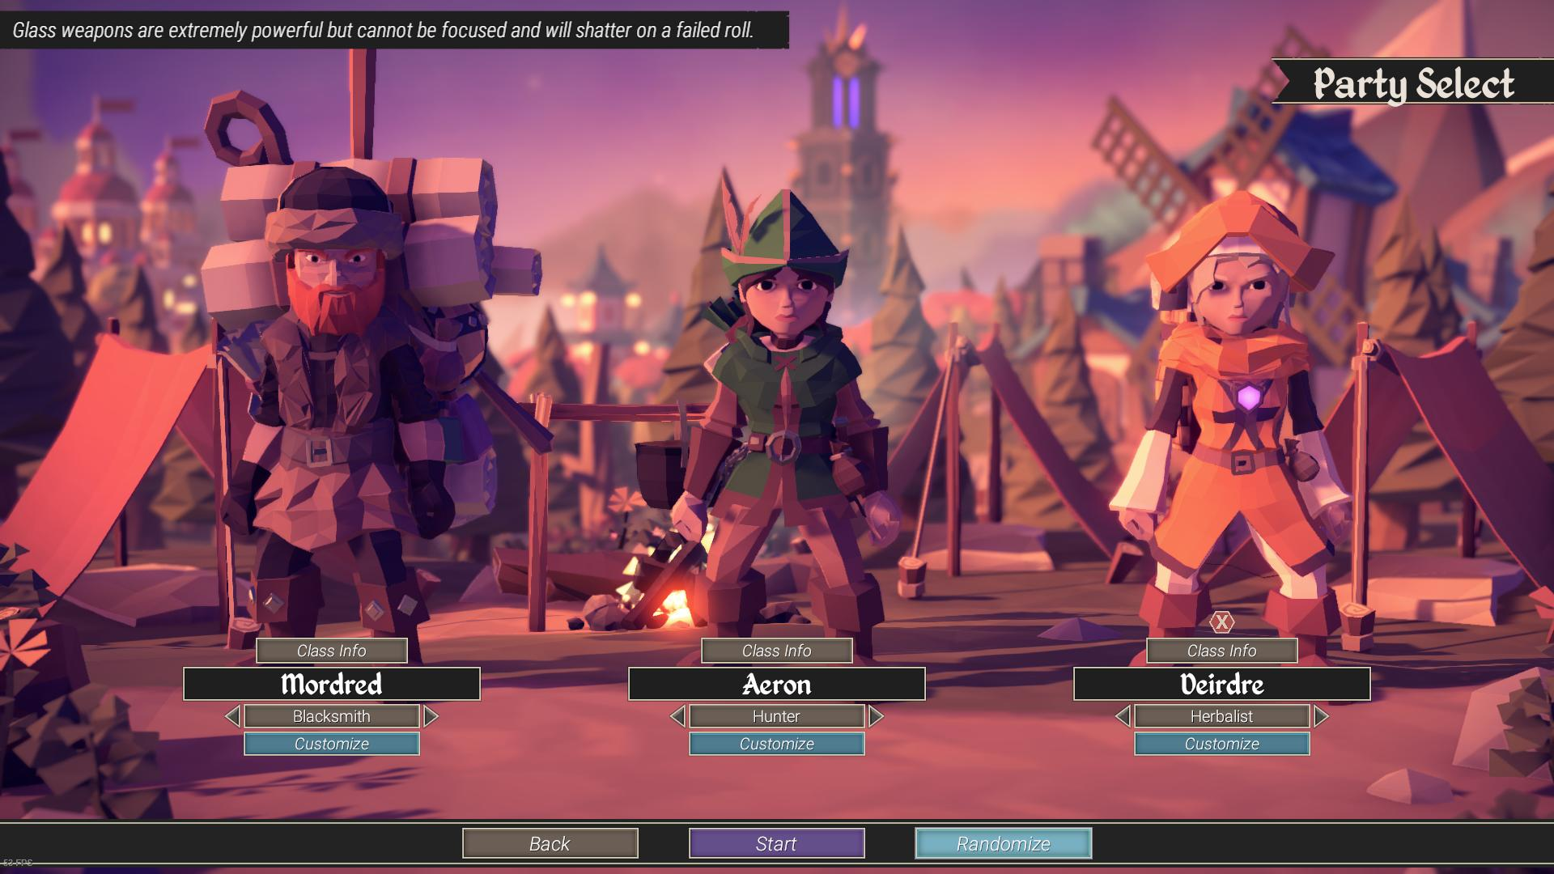

(For the King – Archer)

**Transformation: Cannonier**

The **Cannonier** will be generally characterized by a steampunk vibe, with a short and chunky body, weapons with an exaggerate scale respect of the size of the body, they should looks like being created by a crazy engineer with unpolished components and a lot of gadgets built in.

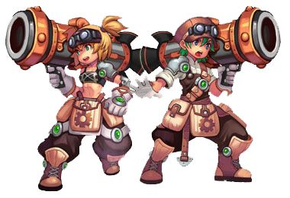

(Nostale’s Cannoneer)

**Transformation: Huntress**

The Huntress will have a slim silhouette, giving her a fragile looks and at the same time sharp weapons with a deadly look.

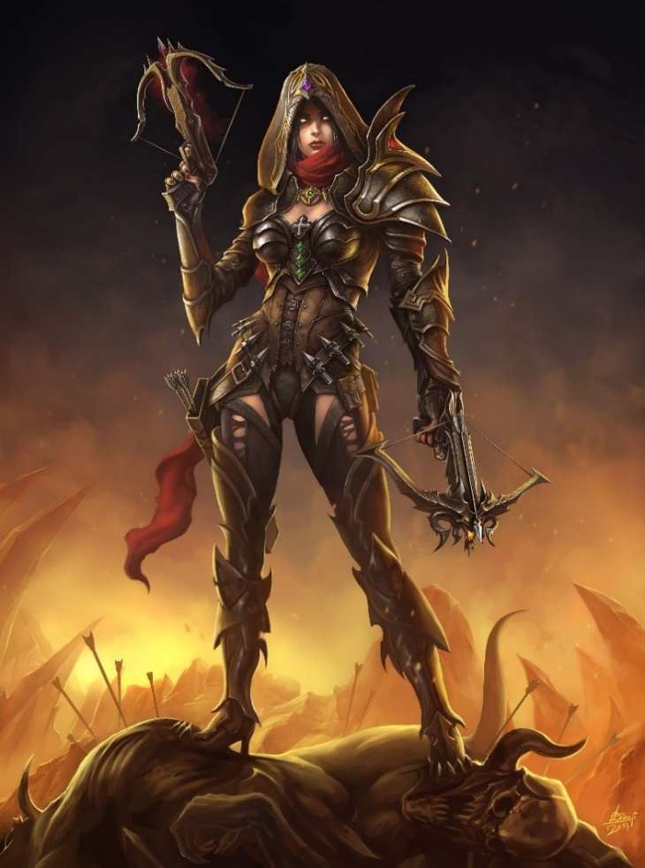

From Diablo 3 – Demon Hunter

**Warrior**

The basic class of the warrior will be characterized by a cheap looking armor without any special traits, giving a general look of a simple soldier.

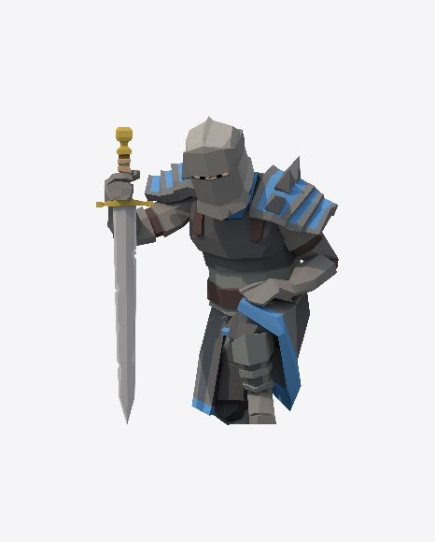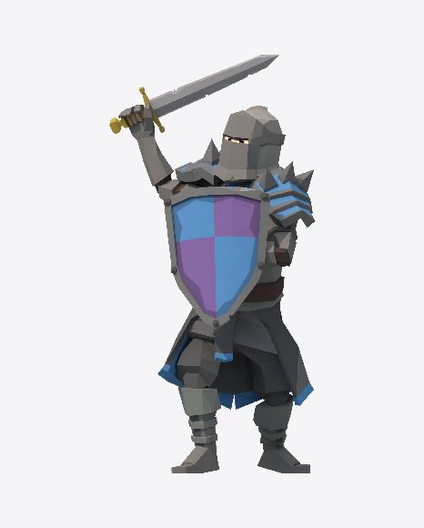

(Basic Warrior)

**Transformation: Paladin**

The paladin will be characterized by a shine armor with an impenetrable look, giving him the impression to be able to stop any incoming damages.

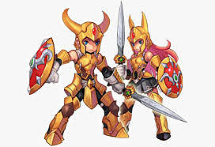

( From Nostale - Gladiator )

**Transformation: Berserk**

The Berserk will be characterized by a huge 2 handed sword, looking too big to be held by a normal soldier. Generally he will looks like an unstoppable and furious warrior that will demolish everything on his path.

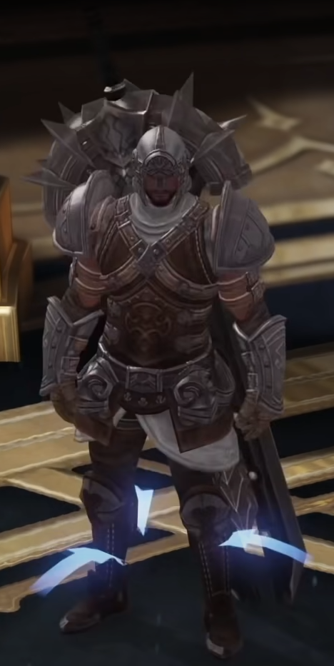

(From Lost Ark - Berserker)

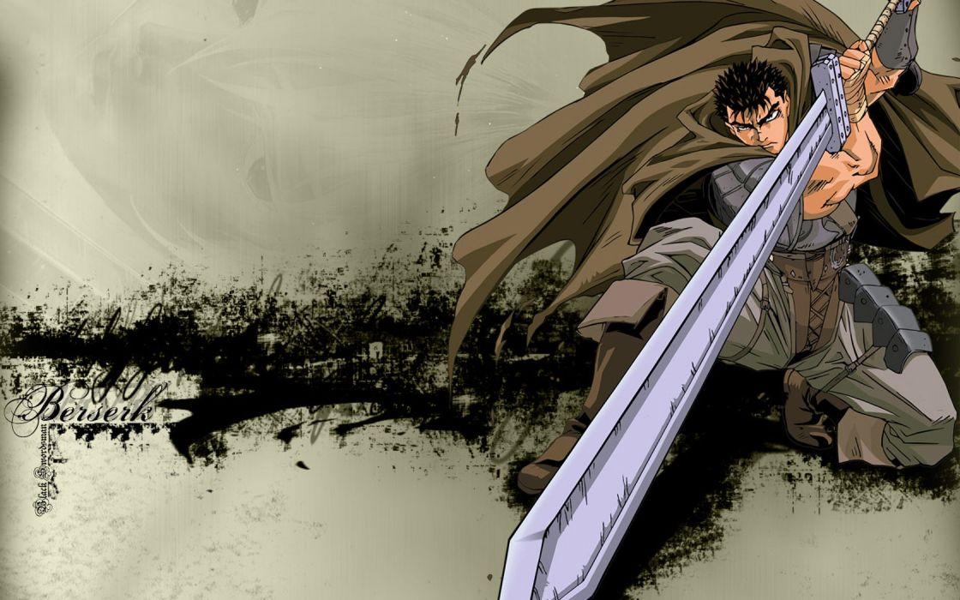

From Berserk

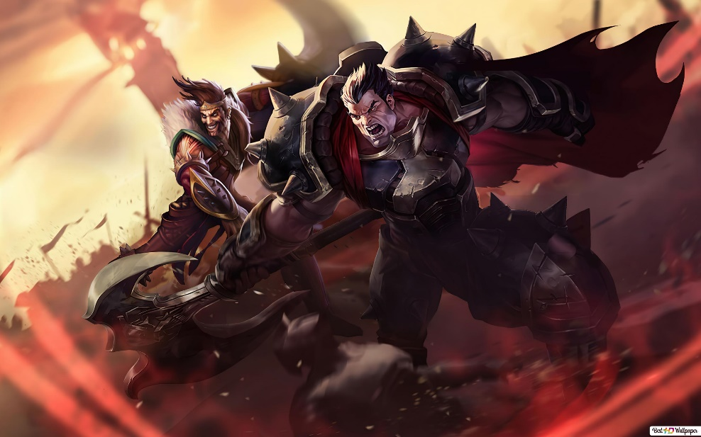

From League of Legends – Darius

**Mage**

The basic mage will be characterized by an almost completely blue tunic, giving him a fragile but wise look.

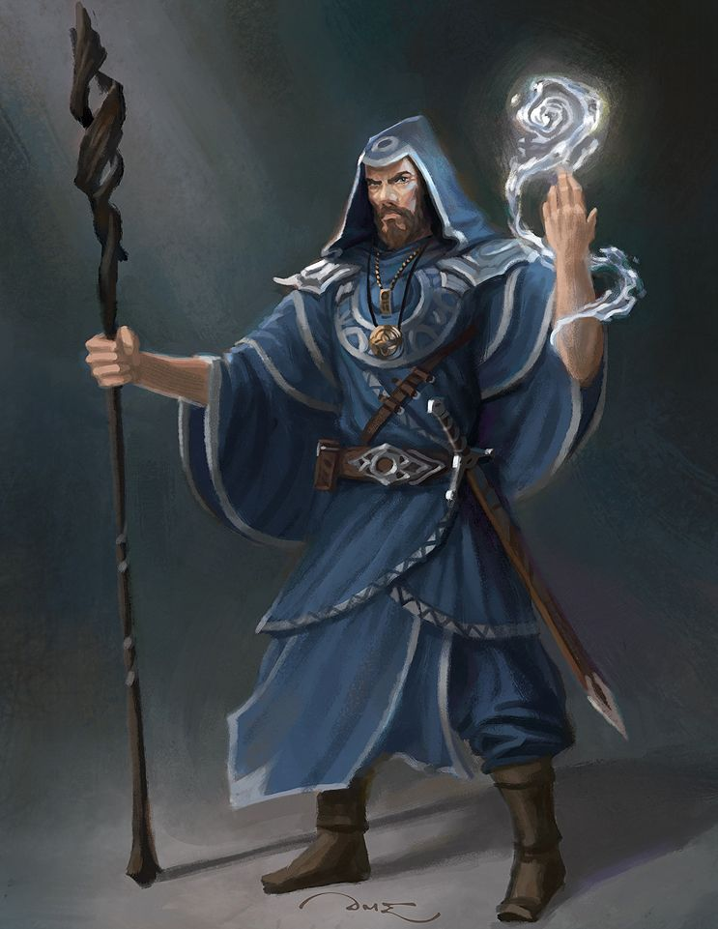

From Gjaldir - DeviantArt

**Warlock**

The warlock will be characterized by a dark and long tunic with multiple shreds attached to it in order to cover his entire skin, giving him a mysterious, dark and frightening look.

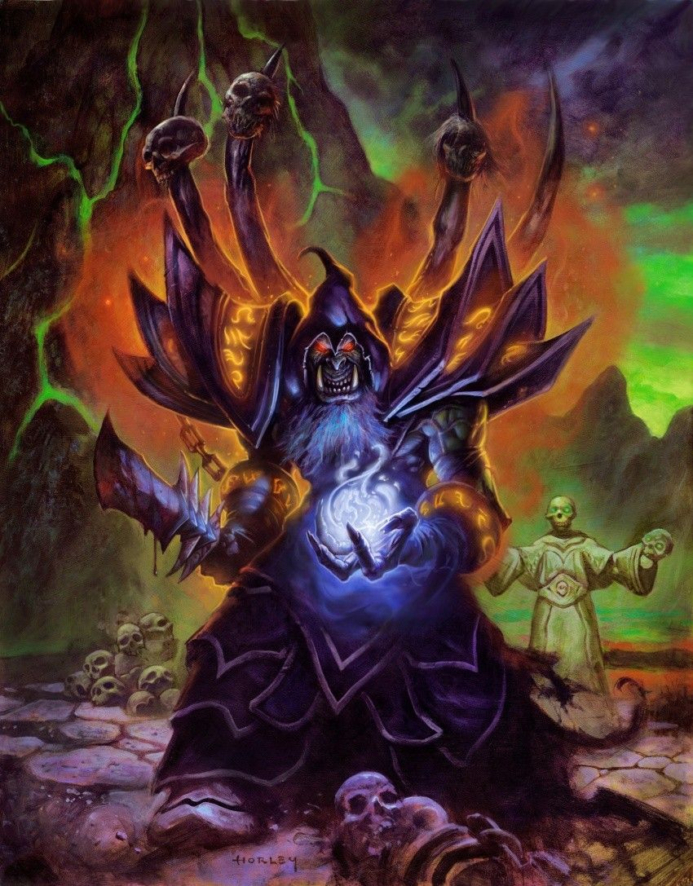

From Hearthstone – Gul'dan

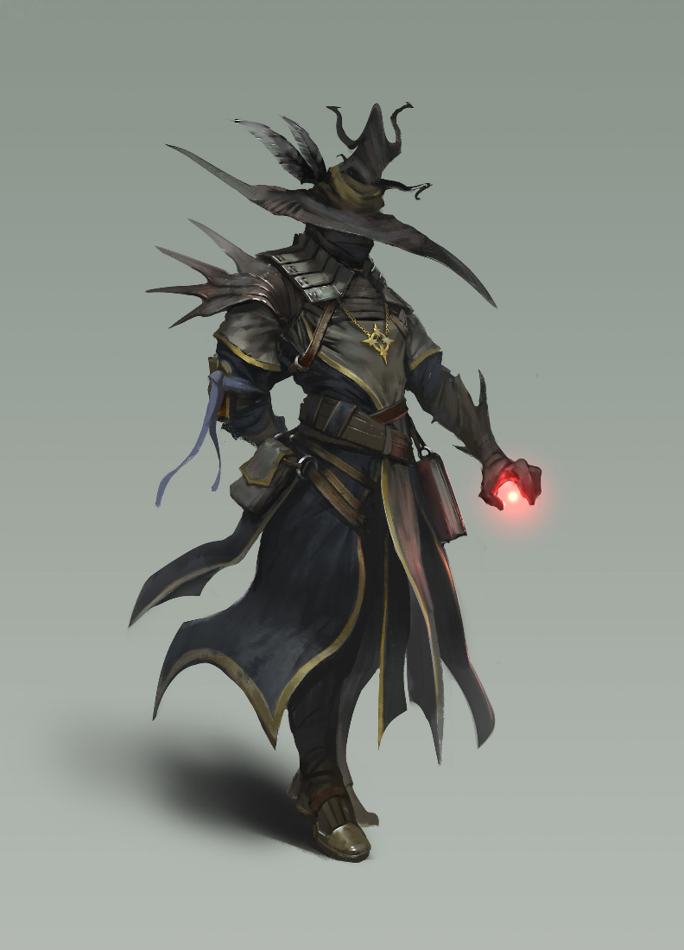

From Mikhail Palamarchuk - ArtStation

**Cleric**

A cleric will be characterized by a clean and white tunic giving him a pure and saint look.

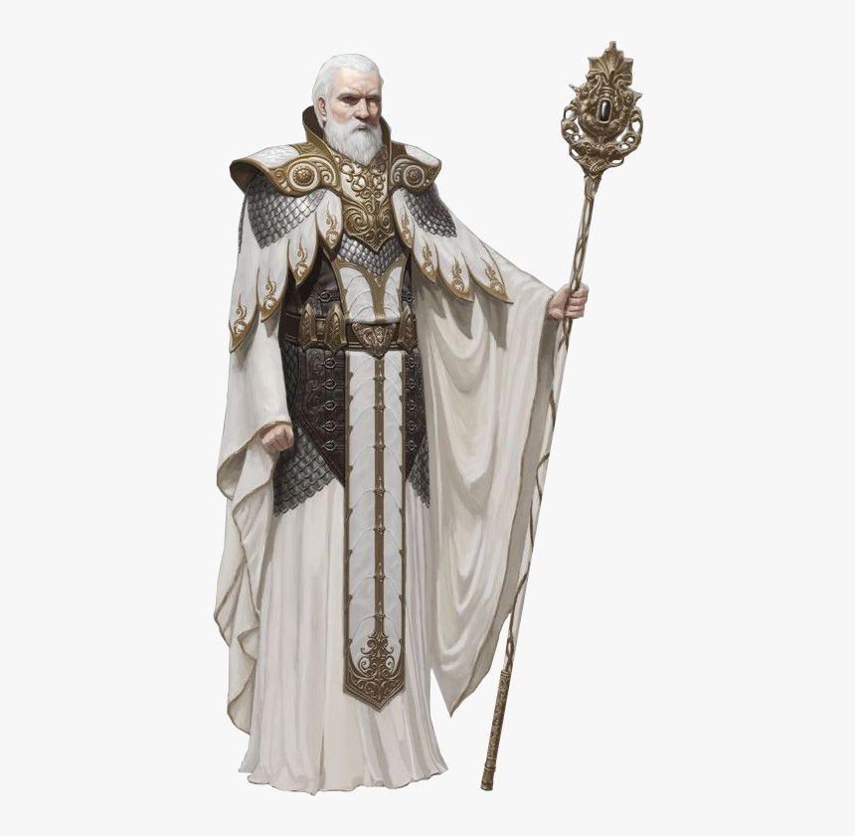

**Heavy Attack**

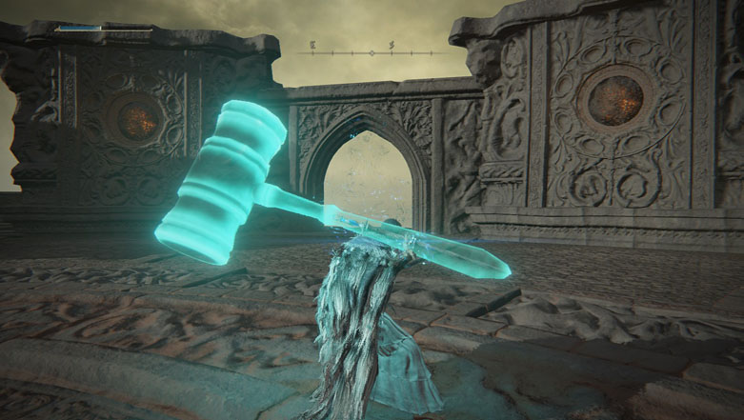

From Elden Ring – Gavel of Haima

## BOSSES

For every boss we need, for each phase of the boss:

* 3D model
* Animations
* SFX for skills, movement
* VFX for skills and movement

Changing from a boss phase to another the 3D model and the rest of media will be slightly similar to the one of the first phase, facilitating the player to keep the focus on the boss and, at the same time, understanding that a new phase of the boss fight has started.

### Calsifer

Calsifer will be characterized by general mixture of dark and red colors, as a remembrance of the Mòn period and the battle to oust their domain on the kingdom.

He will hold a 1 ½ hand sword that will give the flexibility to switch between a 1 hand and a 2 hands style of fighting, proving his expertise and ability in the art of melee combat.

Being a general he will not only looks like a deadly warrior but also a brilliant commander, with an infallible and authoritative look, as every soldier in his army will respect and trust his decisions.

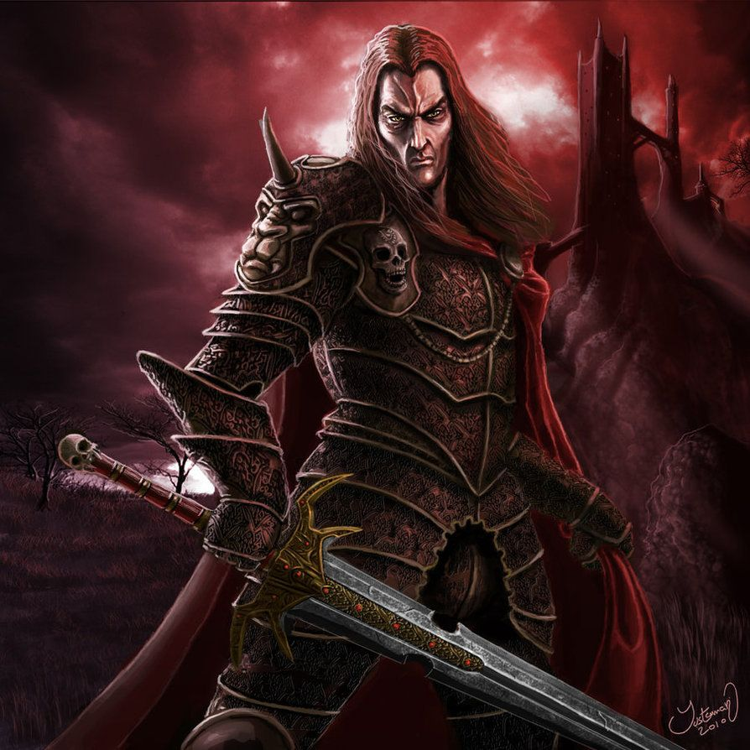

(By ArtOfJustAMan - DeviantArt)

## ENEMIES

For every enemy, boss included, we need:

* 3D model
* Animations
* SFX for skills, movement
* VFX for skills and movement

### Simple Enemy

The simple soldier will look like a fragile and rotten body with low fighting ability.

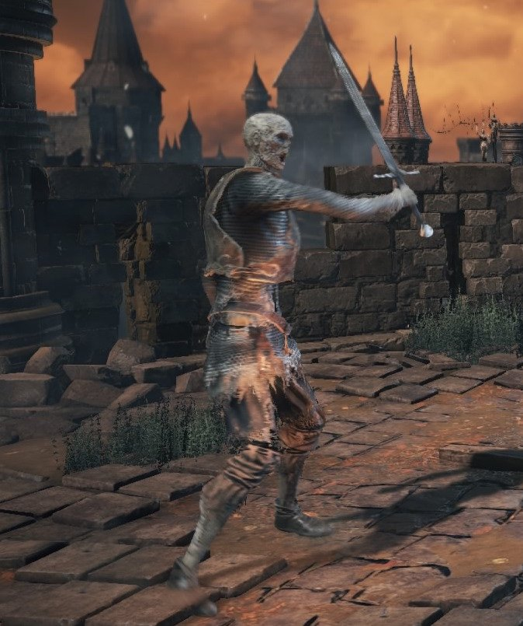

From Dark Souls 3 – Undead Soldier

### Caster

The caster will be characterized as the simple soldier with a rotten body but with a more dangerous look given by his ranged weapon.

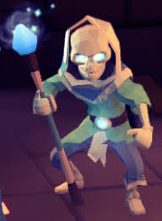

### Summoner

The summoner will generally look like a not so skillful necromancer, with a long tunic with multiple skulls attached to it.

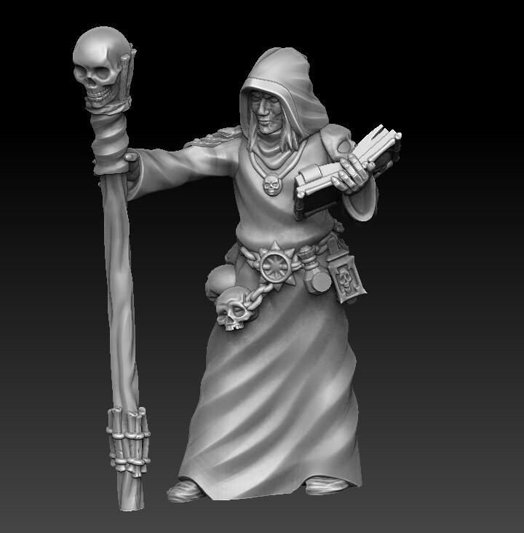

### Blocker

The blocker will be characterized by a rotten body but with a huge shield in his left hand capable of blocking attacks but so heavy to make him slow, on the right hand he will hold a spear with a good range but few damages.

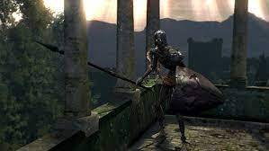

From Dark Souls – Undead with Shield and Spear

### Spider Mother

The Spider Mother will be characterized by a big body, with a swollen abdomen as she was going to hatch some spider eggs. Generally she will have a dreadful look.

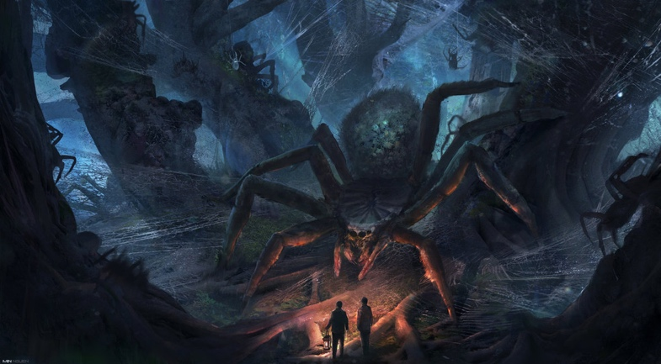

From Harry Potter – Aragog

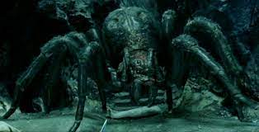

From Lord of the Ring – Shelob

### Spiderling

Spiderling will look like a smaller and less harmful version of the Spider Mother.

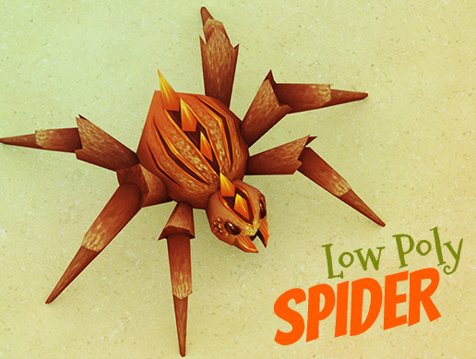

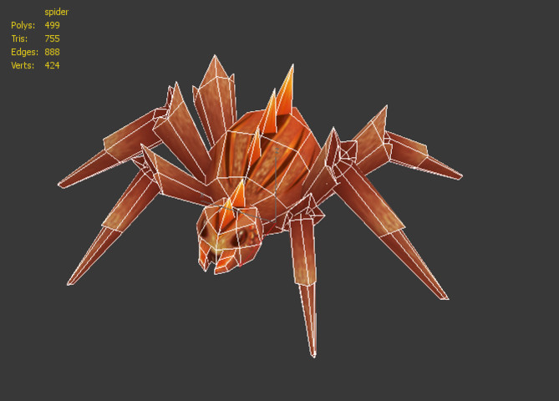

From <https://assetstore.unity.com/packages/3d/props/weapons/free-low-poly-swords-189978>

### Suicide

This enemy will have a rotten body, with a crazy look as someone willing to let himself explode to cause some damage to the player.

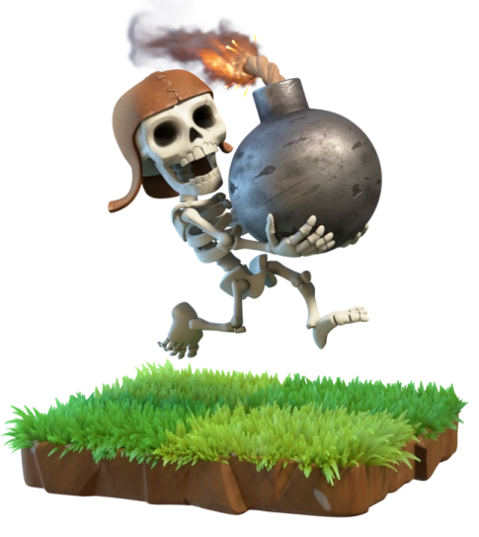

From Clash of Clans – Wall Breaker

### Crimson Tentacle

Crimson Tentacle will be characterized by a general red color, a squishy body covered by octopus suckers and spines giving him a frightening and dangerous look.

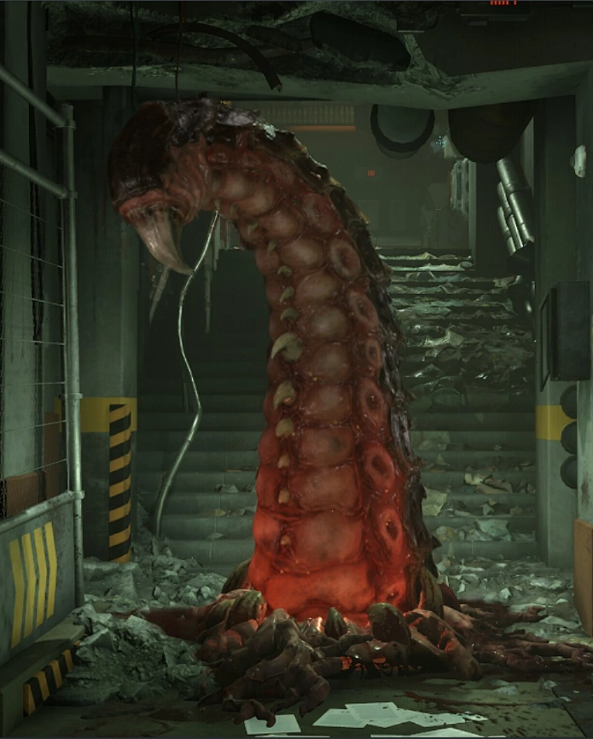

From Doom Eternal - Tentacle

## ENVIRONMENTS

### Hub

They will have an unharmful look, as a resting place where player can stay in peace.

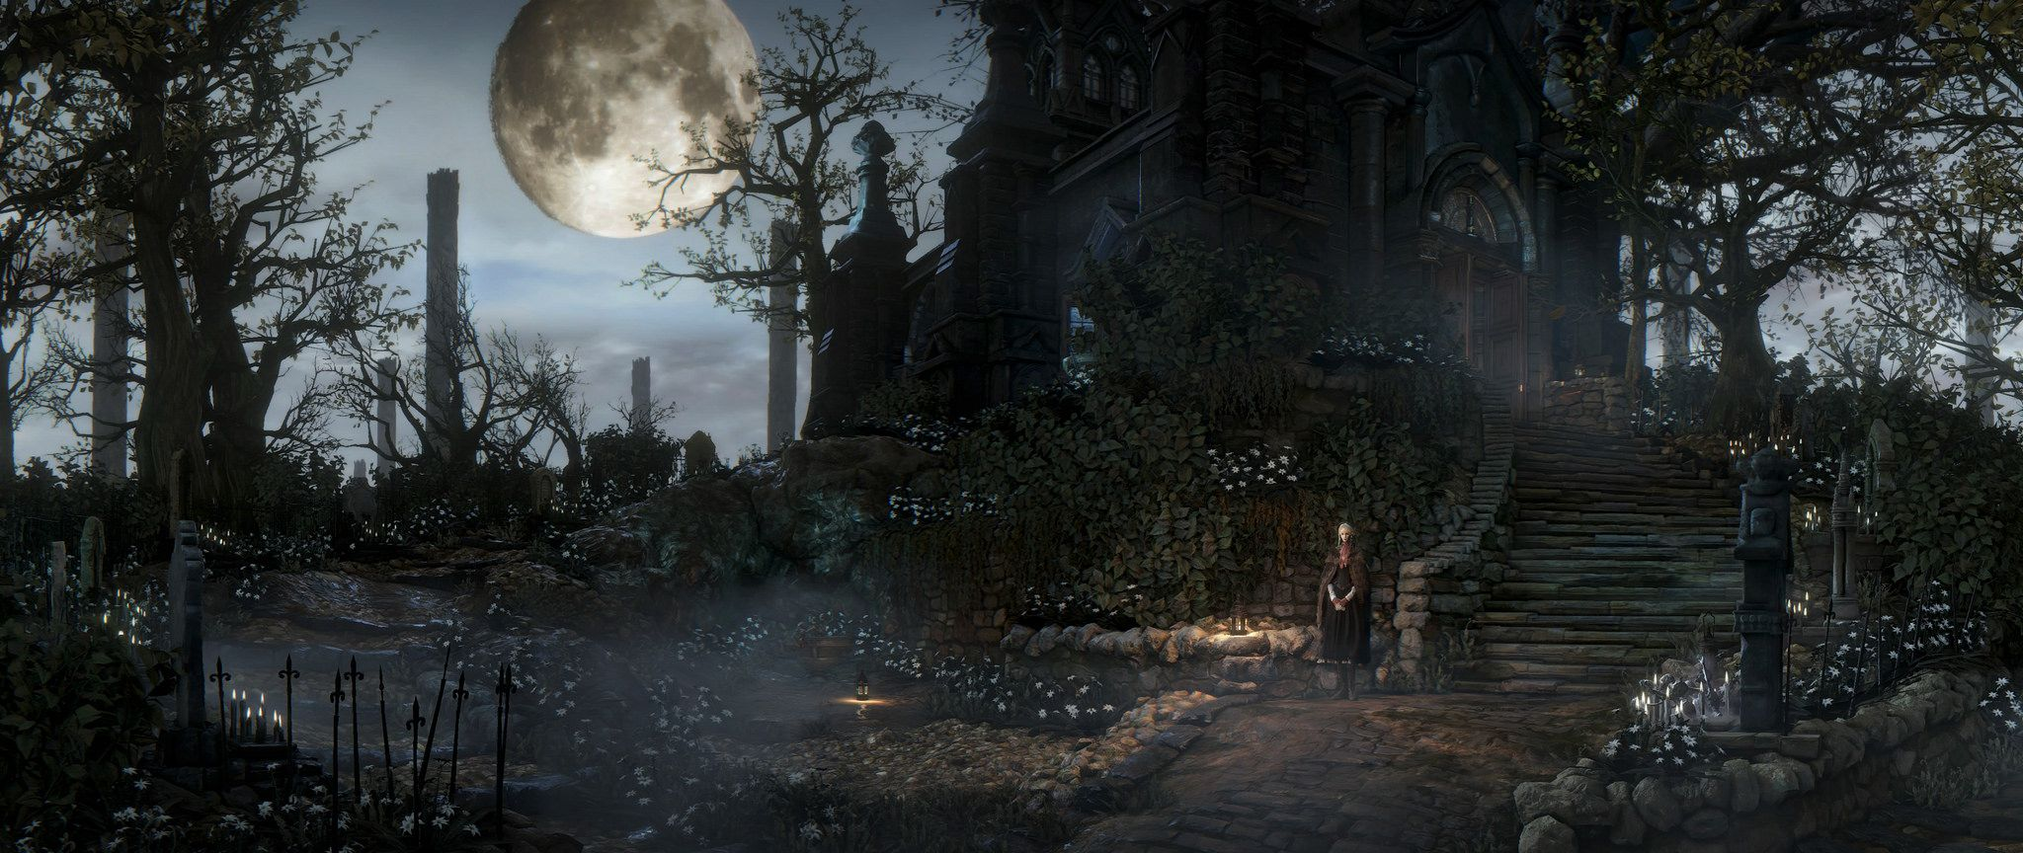

### Dungeon rooms

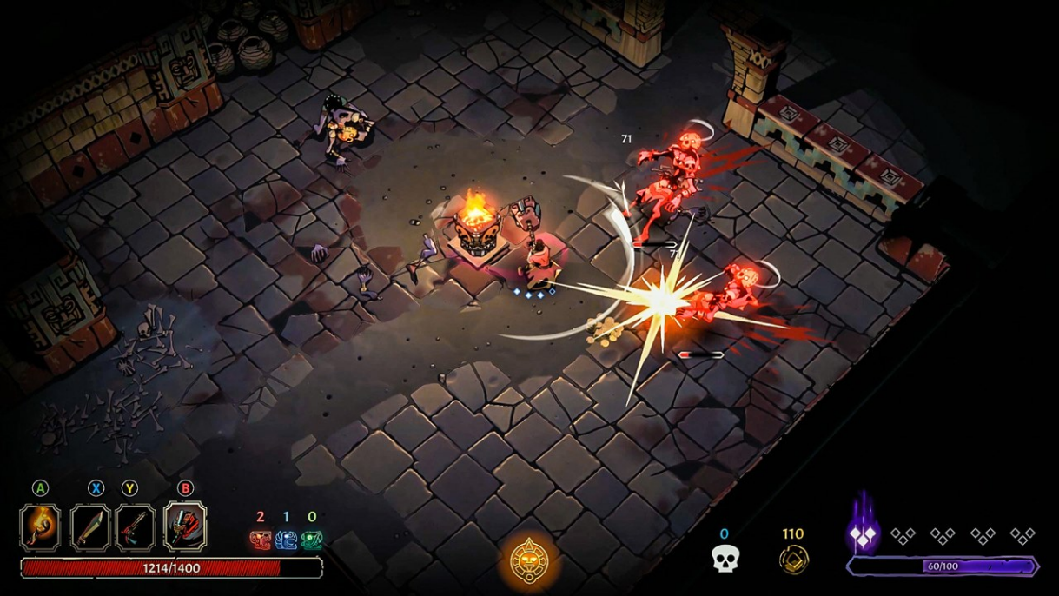

### Red Lands

The environment in which the dungeon will take place will have a general red look, given by the ferocious battle where many soldiers fell, reversing so much blood on the ground that it turned red.

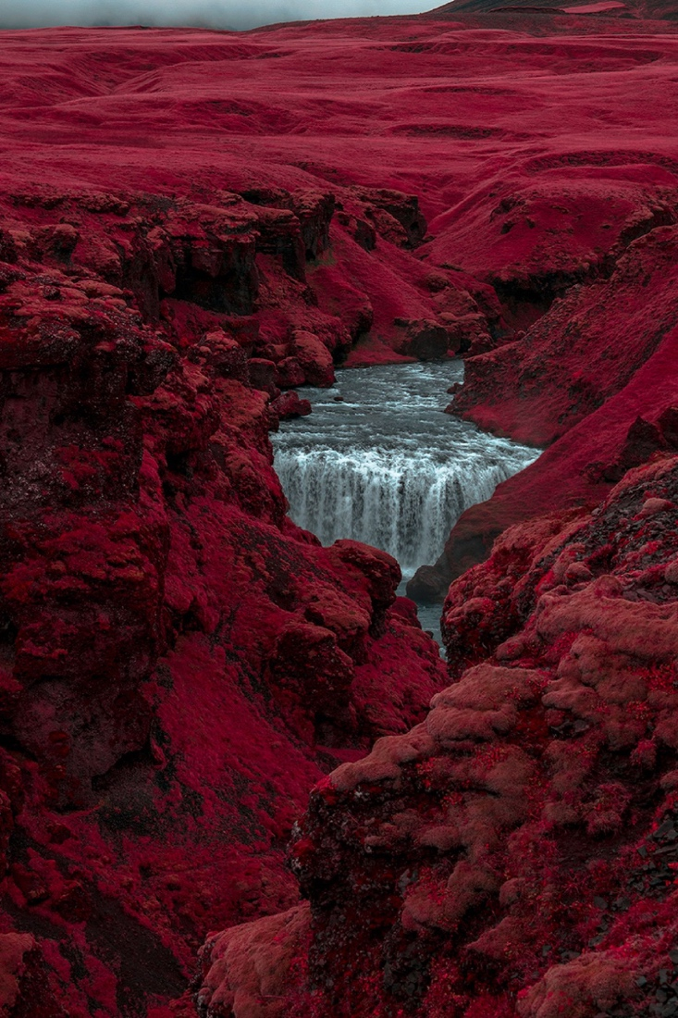

## MUSIC

* Carian boss fight:
  + <https://www.youtube.com/watch?v=iq1aFWw7NAs>
  + <https://www.youtube.com/watch?v=DDs5sDfXs5Q> (09:30 Litz & Nepac the Cursed Twins Catacombs
* hub
  + <https://www.youtube.com/watch?v=1EISe-WdZYE&list=PLKzg0DeoAjD-cGZOEspgvDGpFal8S2aS-&index=3>
* Main menu
  + <https://www.youtube.com/watch?v=L6JH0EfTIKw>
  + <https://www.youtube.com/watch?v=dKQ3aIPP7-0>
  + <https://www.youtube.com/watch?v=tOBq_7BoYlM>
* Dungeons
  + <https://www.youtube.com/watch?v=nRLrSOc2654>
  + <https://www.youtube.com/watch?v=KW0QTWpcjc0>
  + <https://www.youtube.com/watch?v=DDs5sDfXs5Q> (05:51 Xak'olchir, the Blood Hunter)
  + <https://www.youtube.com/watch?v=fkVU0-L3vP0&list=PLombWqRALIZDwEsPJuGvD6soVFA46I7f2&index=3>

**Game Art Reference**

* **Tunic**

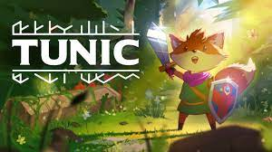

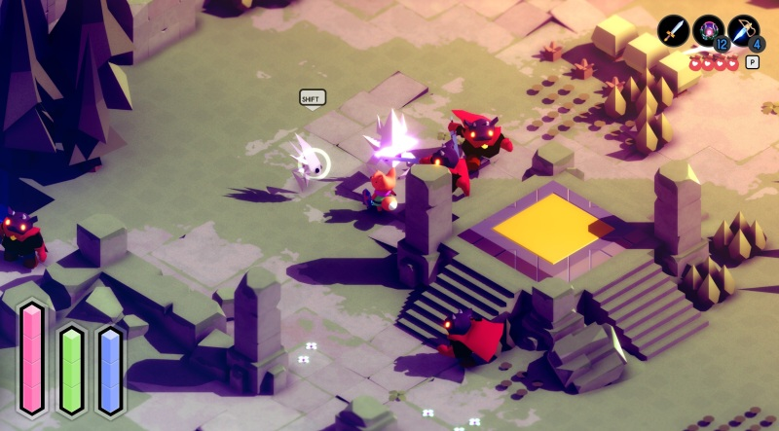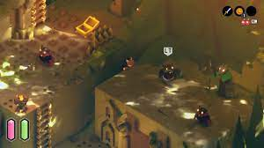

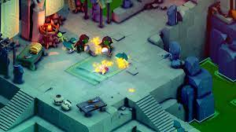

* **For the King**

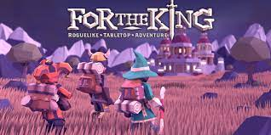

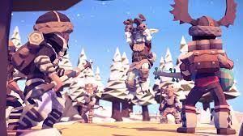

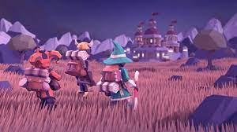

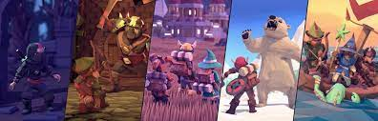

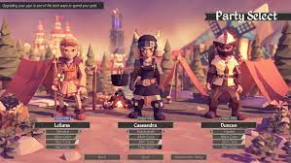

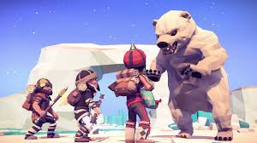

## CARIAN DEPTHS

Carian depths will be characterized by a labyrinthic structure, where rooms tent to look alike since they are characterized by a dark, filthy and claustrophobic look where every sort of dangerous creatures could live.

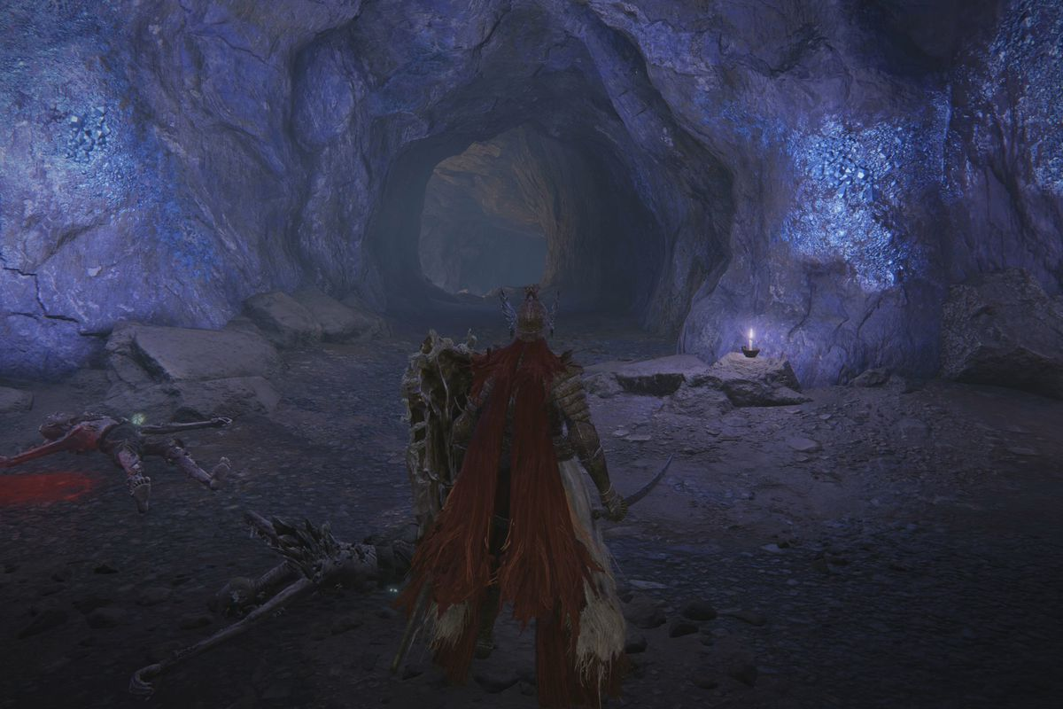

# PROTOTYPES

## PHYSICAL PROTOTYPE

To help the development of Let Me R.I.P. we made a physical prototype using pen and paper, in order to realize it in a short period of time and to make it flexible, allowing us to easily make multiple changes to the mechanics of the game.

During the testing we focused on player movement and stats, size of the rooms, number and position of enemies and their behavior.

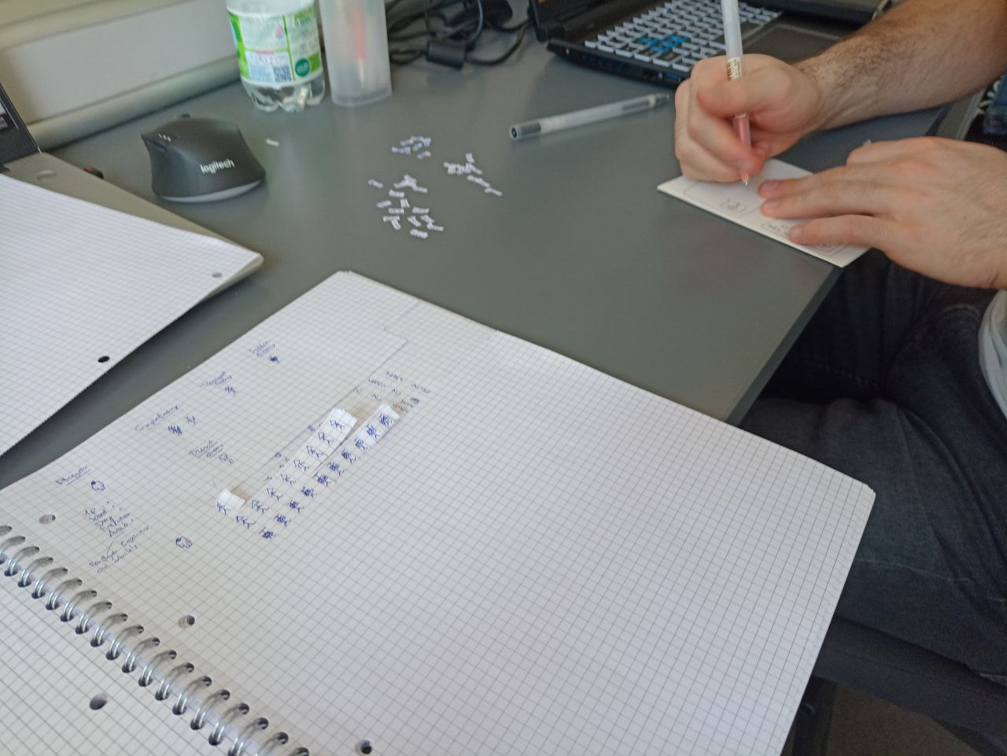

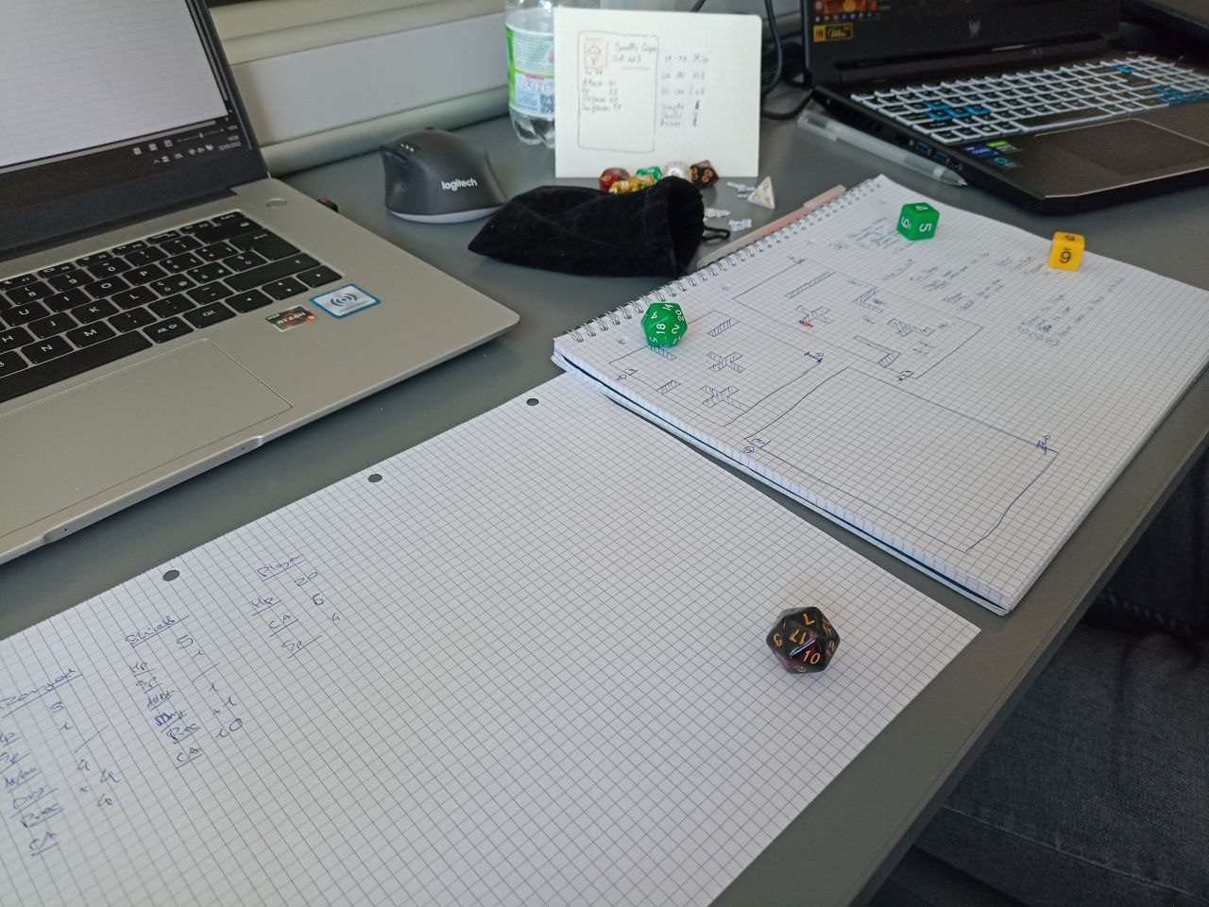

We started creating multiple rooms of different sizes and with different obstacles number, shape and location. Then we populate rooms with different number and types of enemies.

We used dices to simulate:

* damage calculation
* player’s skill to avoid hits
* Enemy ability to hit the target

The turn structure was:

* Player moves
* Player attacks
* Enemies move
* Enemies attack

This turn structure was intended to simulate better the type of player we are designing the game for: hardcore player.

From this test we found out that enemies with range attacks were really too strong especially when they were protected by melee enemies and when they were in an open space.

After reworking obstacle position and number, the game resulted more balanced.

To give a more believable we changed enemies’ behavior:

* melee enemies keep chasing the player even if he is out of sight but still near
* ranged enemies will stop attacking and chasing the player when he is out of sight, but he will go to his last seen position.

From this test we also understood that, based on these behaviors, the position of obstacles in the room and its sized was really the key to control the difficulty of the room, allowing players to pull enemies few at the time, to fight them in an easier without being targeted by ranged enemies.

The next phase of the physical prototype was focused on balancing the statistics of the player and his damage output based on enemies' statistics.

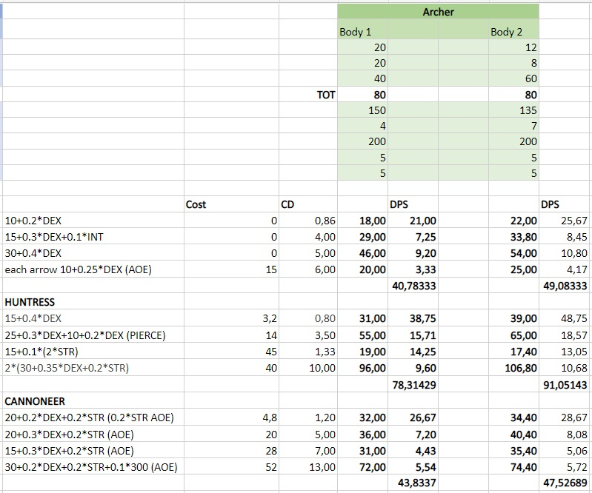

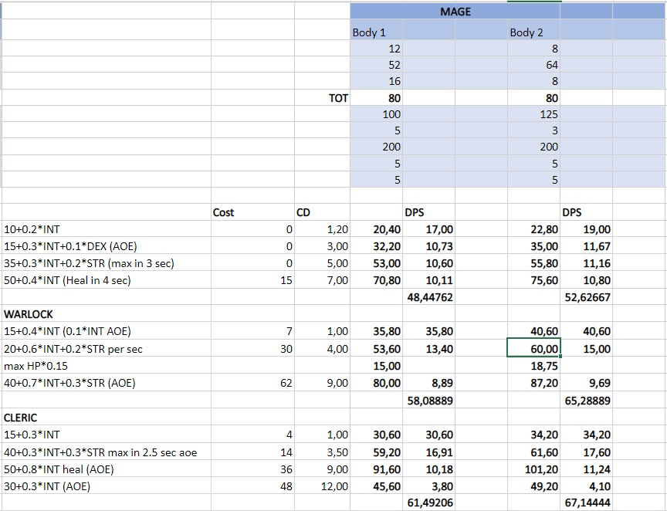

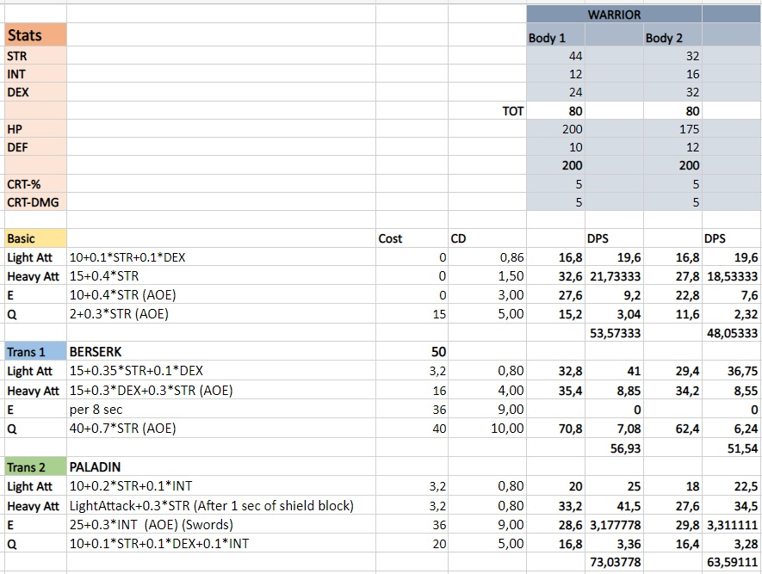

## DIGITAL PROTOTYPE

Inside the digital prototype will be implemented only a fraction of what is contained inside this document. The digital prototype will include networking and will include core mechanics of the game: basic movement and attacks, abilities and spirit point gathering, a reduced number of classes and transformations.

From this prototype we think that someone could get the understanding of the core gameplay and its mechanics.

Not all classes, transformations, items and media that are in this document will be contained and implemented in the prototype.